**Git:**

Git is a free and open source distributed version control system designed to handle everything from small to very large projects with speed and efficiency.

Difference between git and github:

Git is a version control system that allows you to track changes to your code, and it is a great way to keep track of your work. It is also a great way to share your code with others, and it can be very useful when you are working on a project that involves a lot of collaboration.

Github is a web-based Git repository, that is. Cloud-based storage is offered by this hosting company. Git’s distributed version control and source code management capabilities are all provided by GitHub, along with some additional features. Utilising Git facilitates collaboration. The public can access GitHub repositories as well. GitHub serves as a networking platform for online professionals since developers from all over the world may engage, contribute to one another’s code, and edit or improve it. Social coding is another name for the process of participation and engagement.

Differencebetween git and svn:

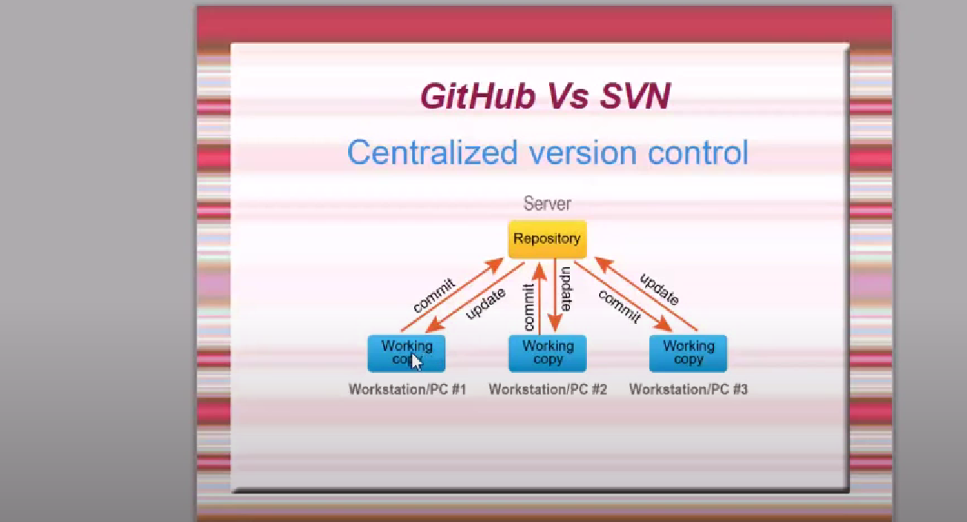

u must have internet connection.

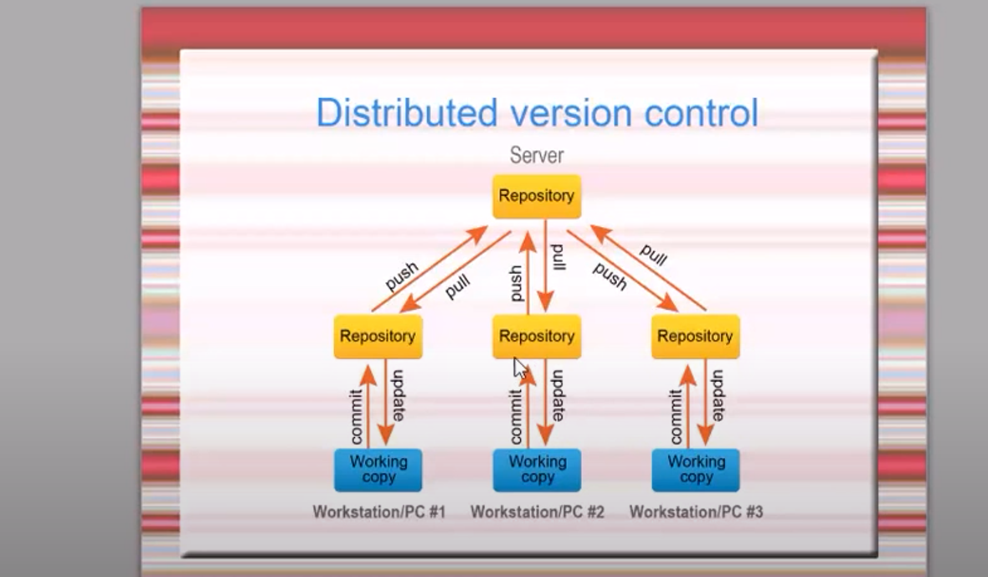

SVN:

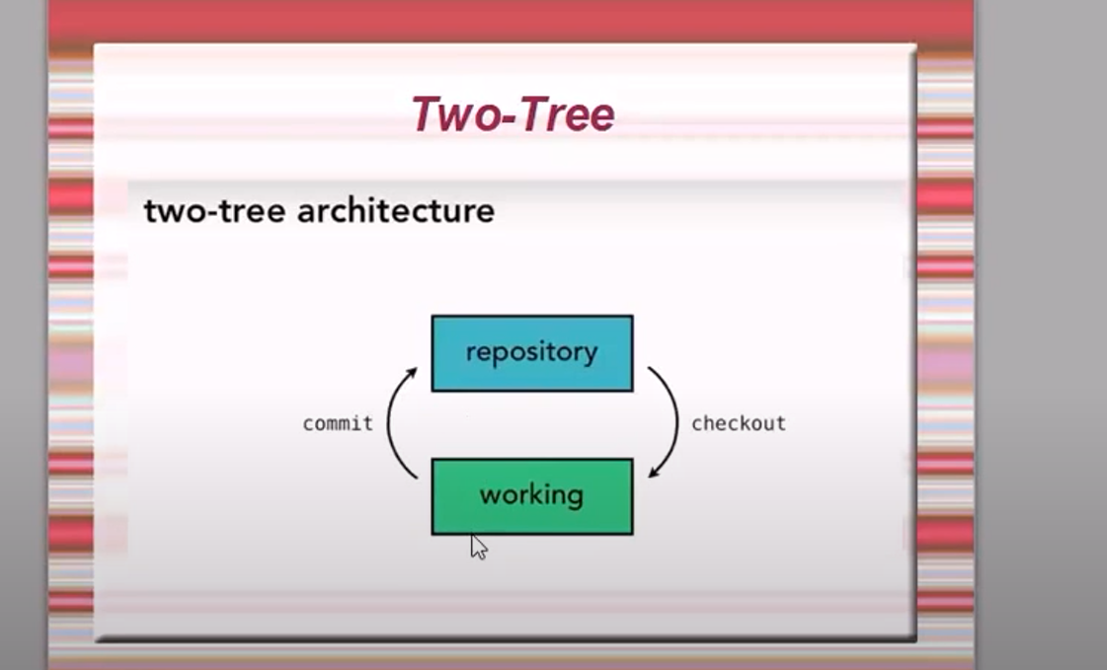

GIT:

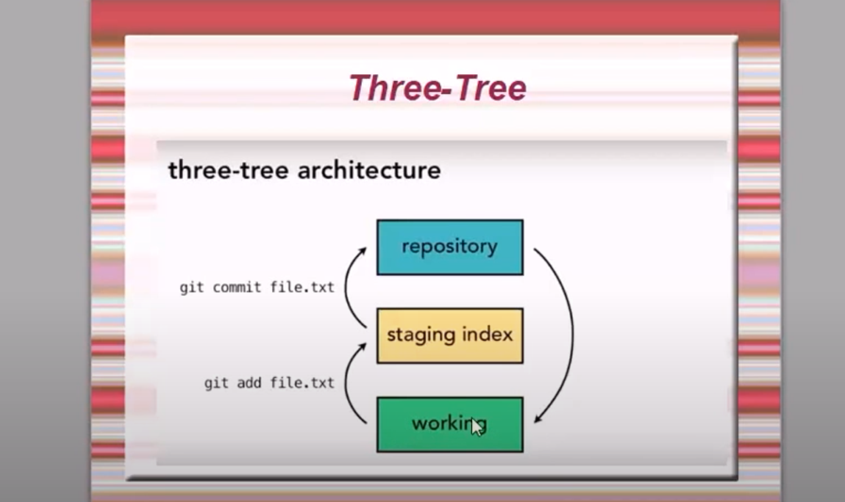

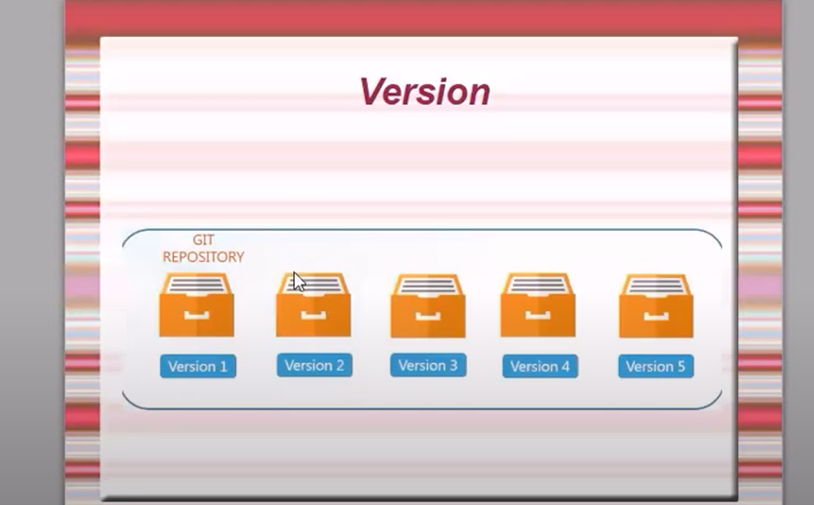

Every changes there will be a version.

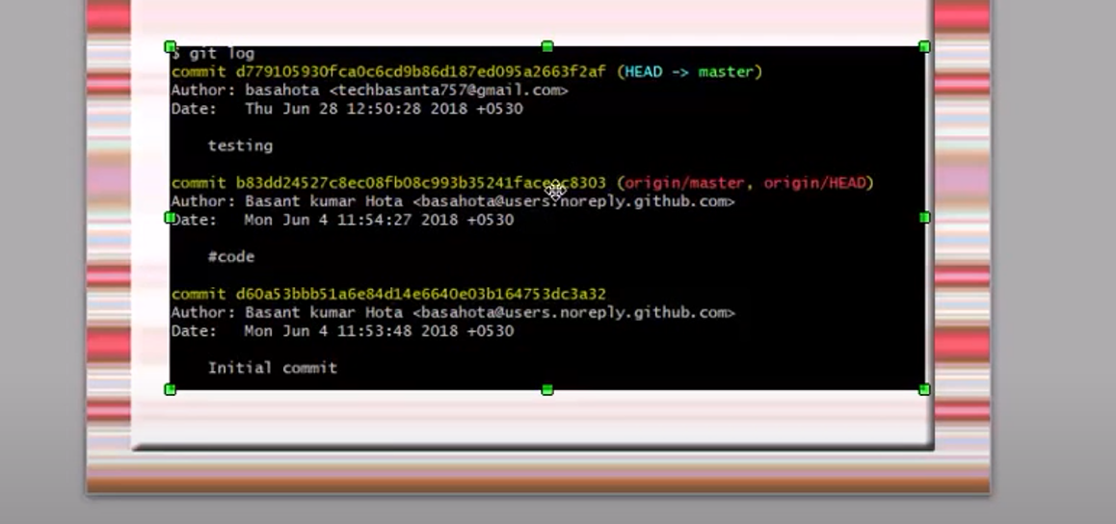

Need to install git using below command

<https://git-scm.com/downloads>

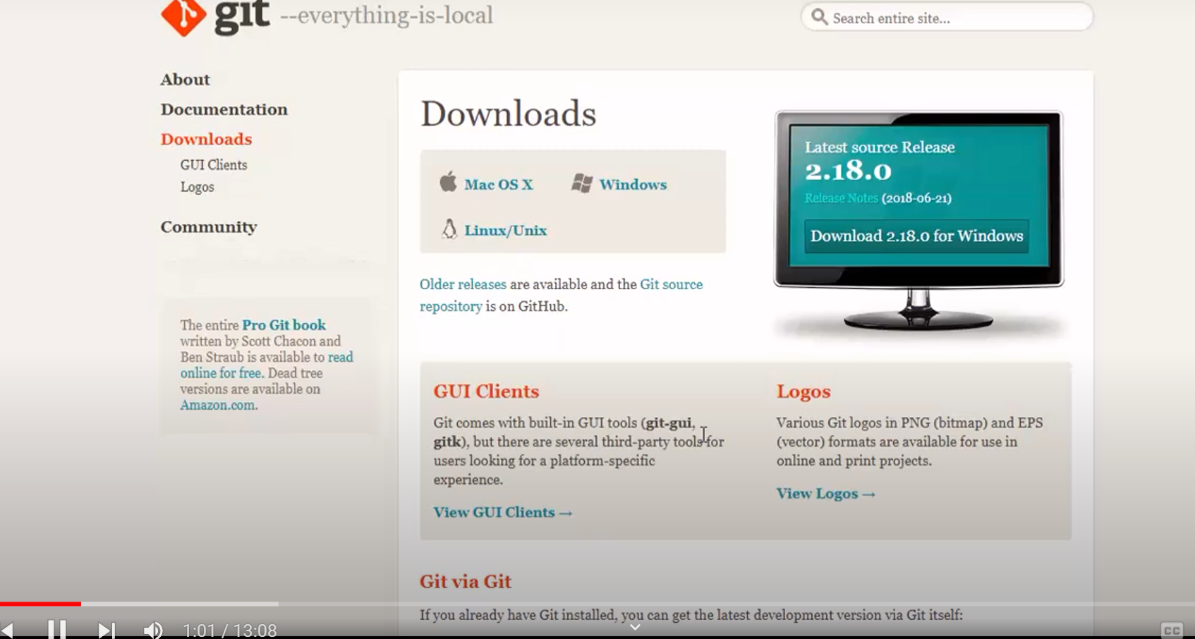

Click on download2.18.0 for windows

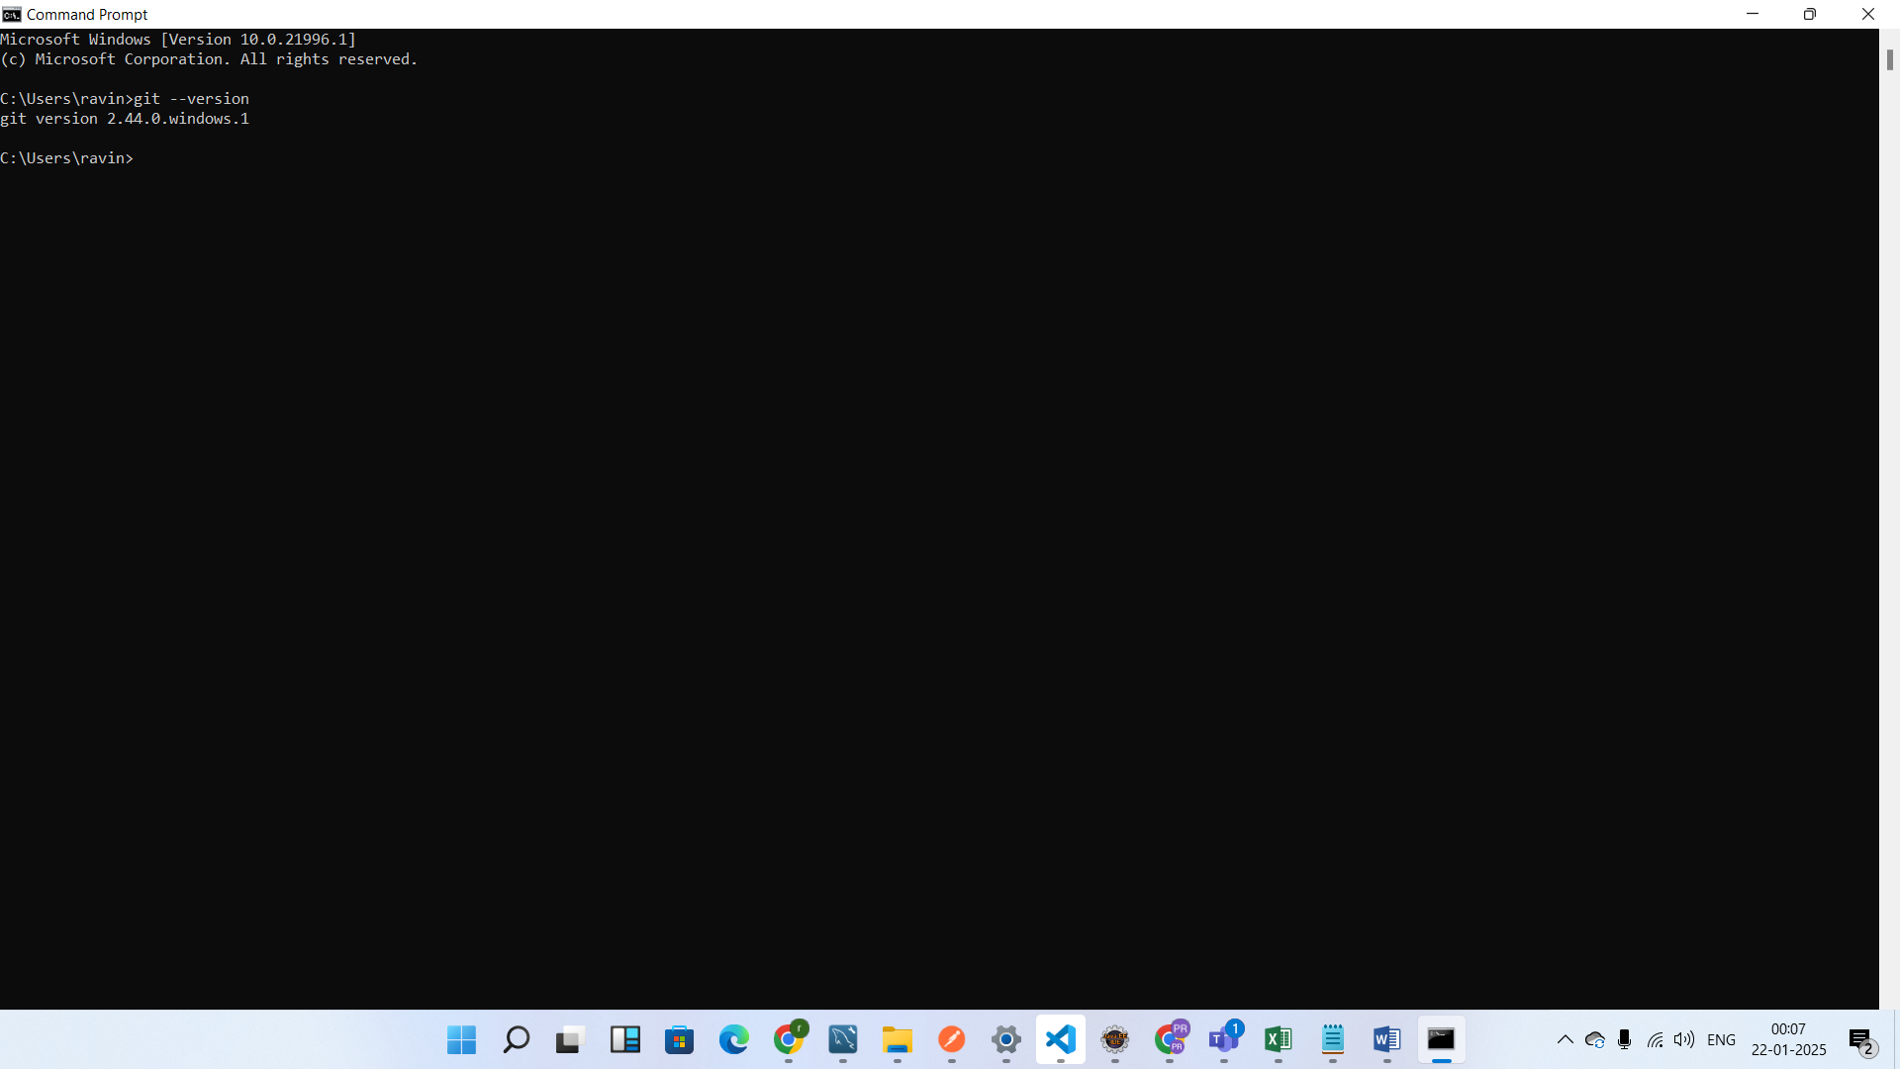

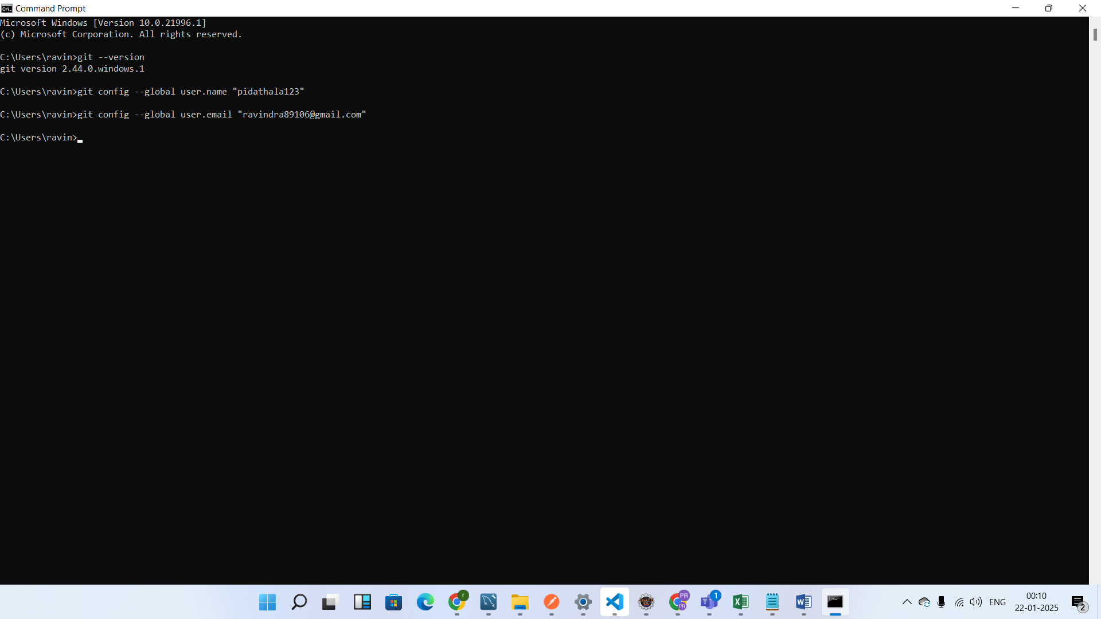

Step1) Create the java project

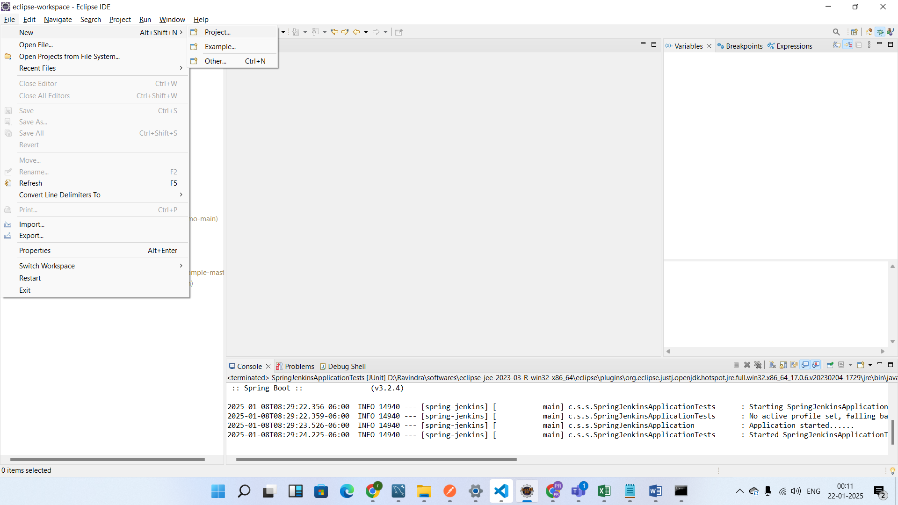

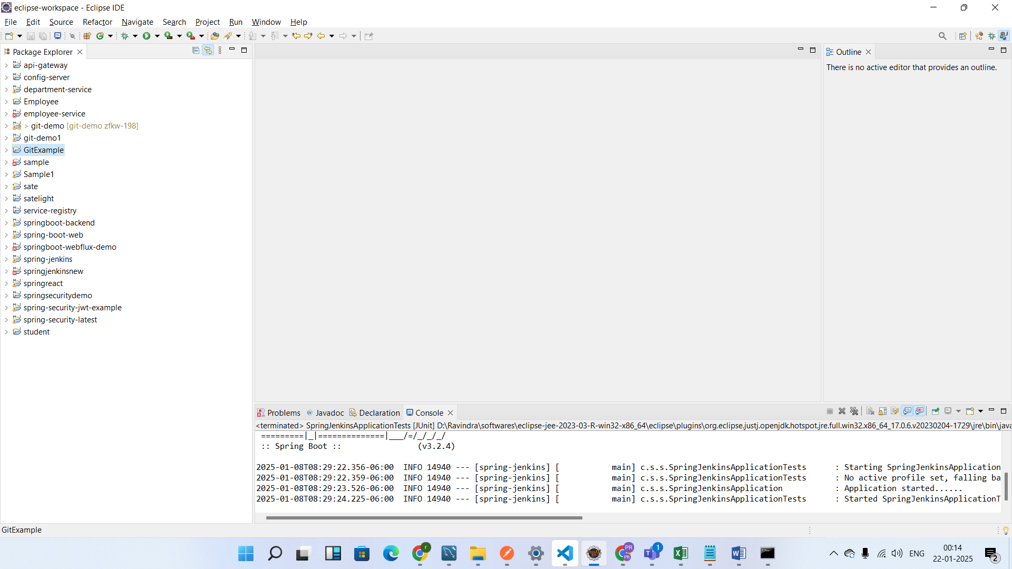

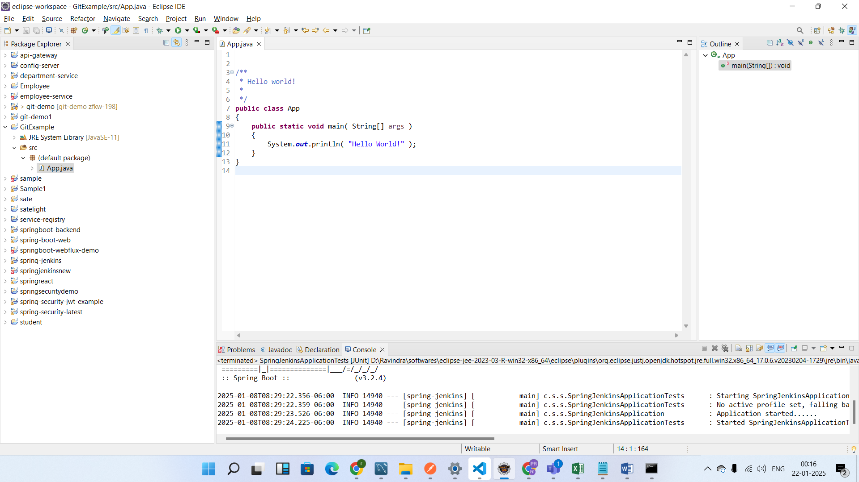

Now go to the project directory and do the git bash here

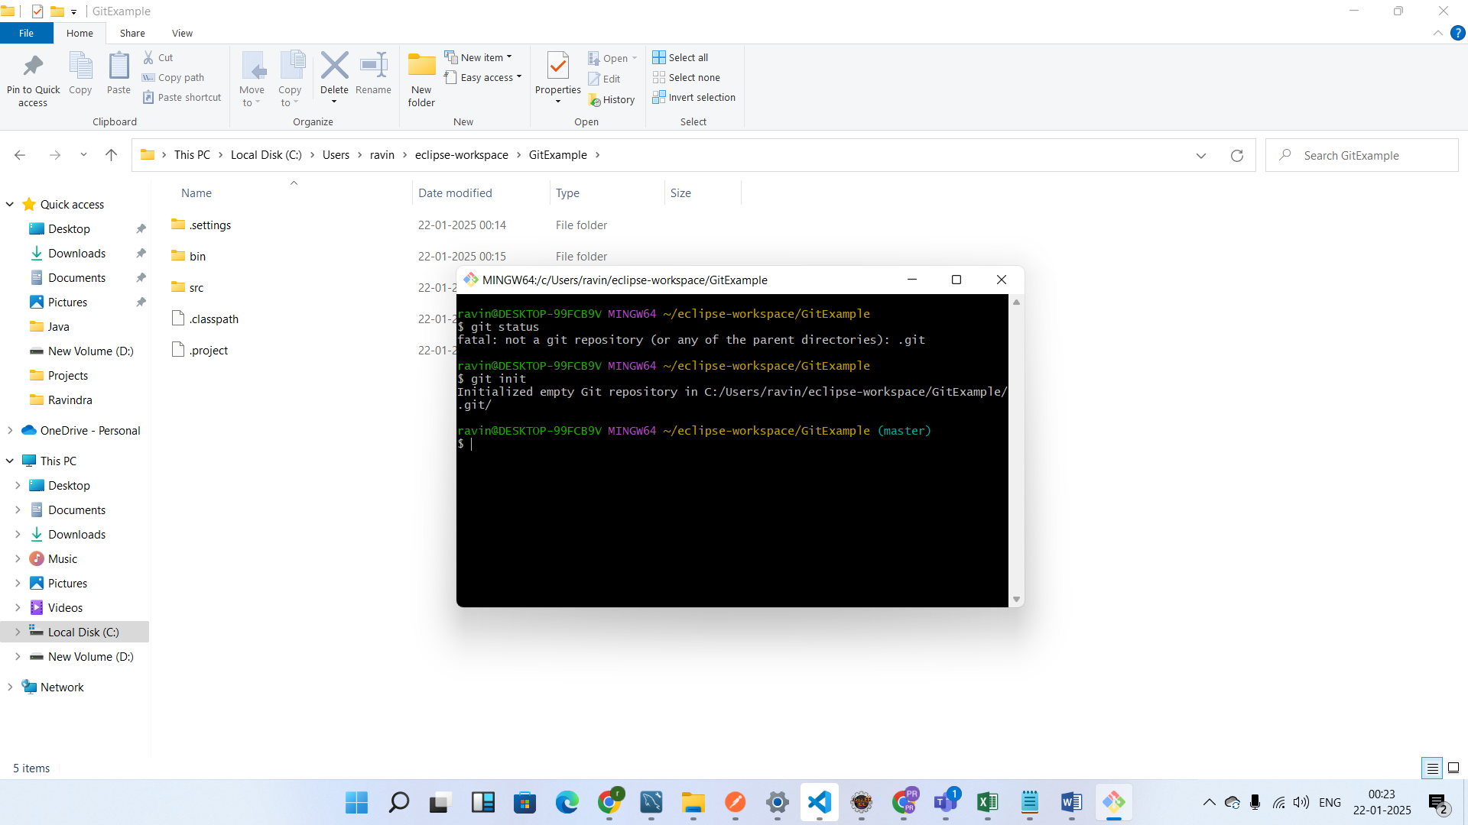

Now check changes in the code using git status

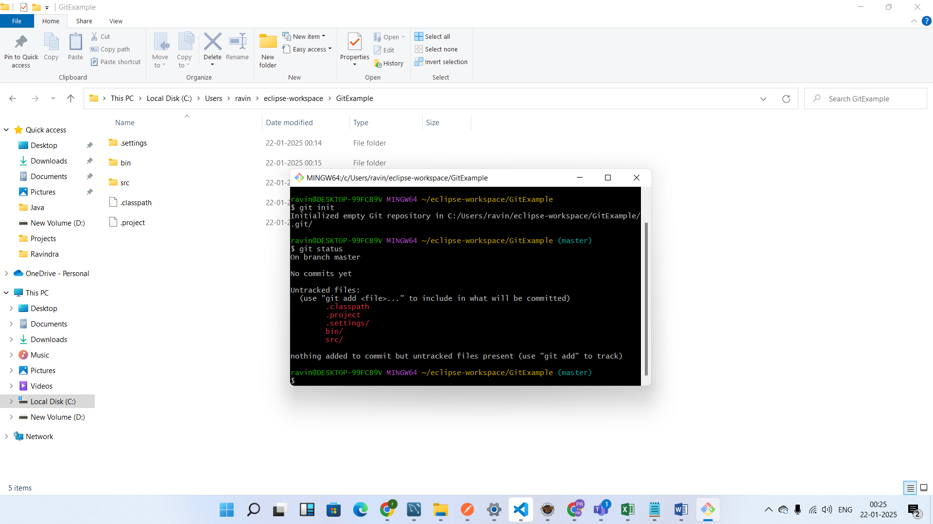

Git add .

It will add all the files to the staging area

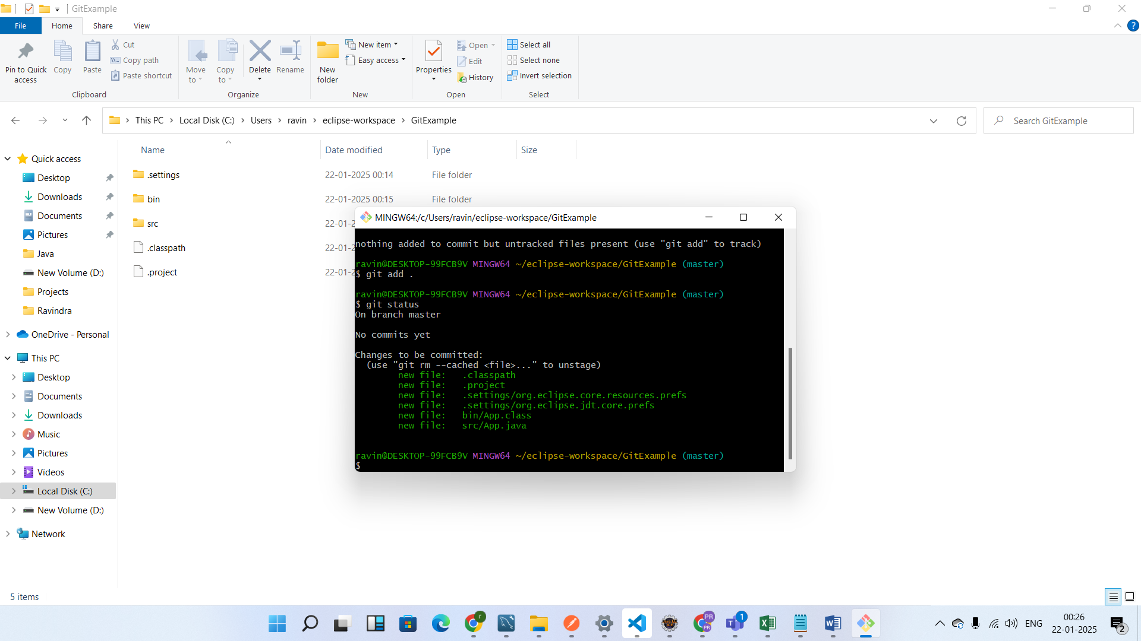

Now add the all the files to the local repository for that need to use command called

Git commit –m “commit message any thing”

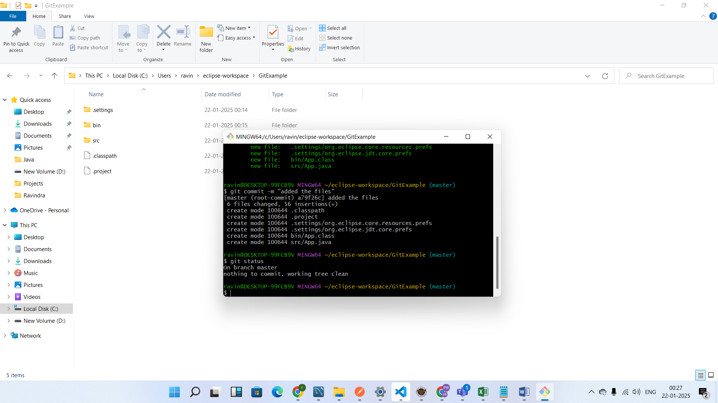

Now check git log

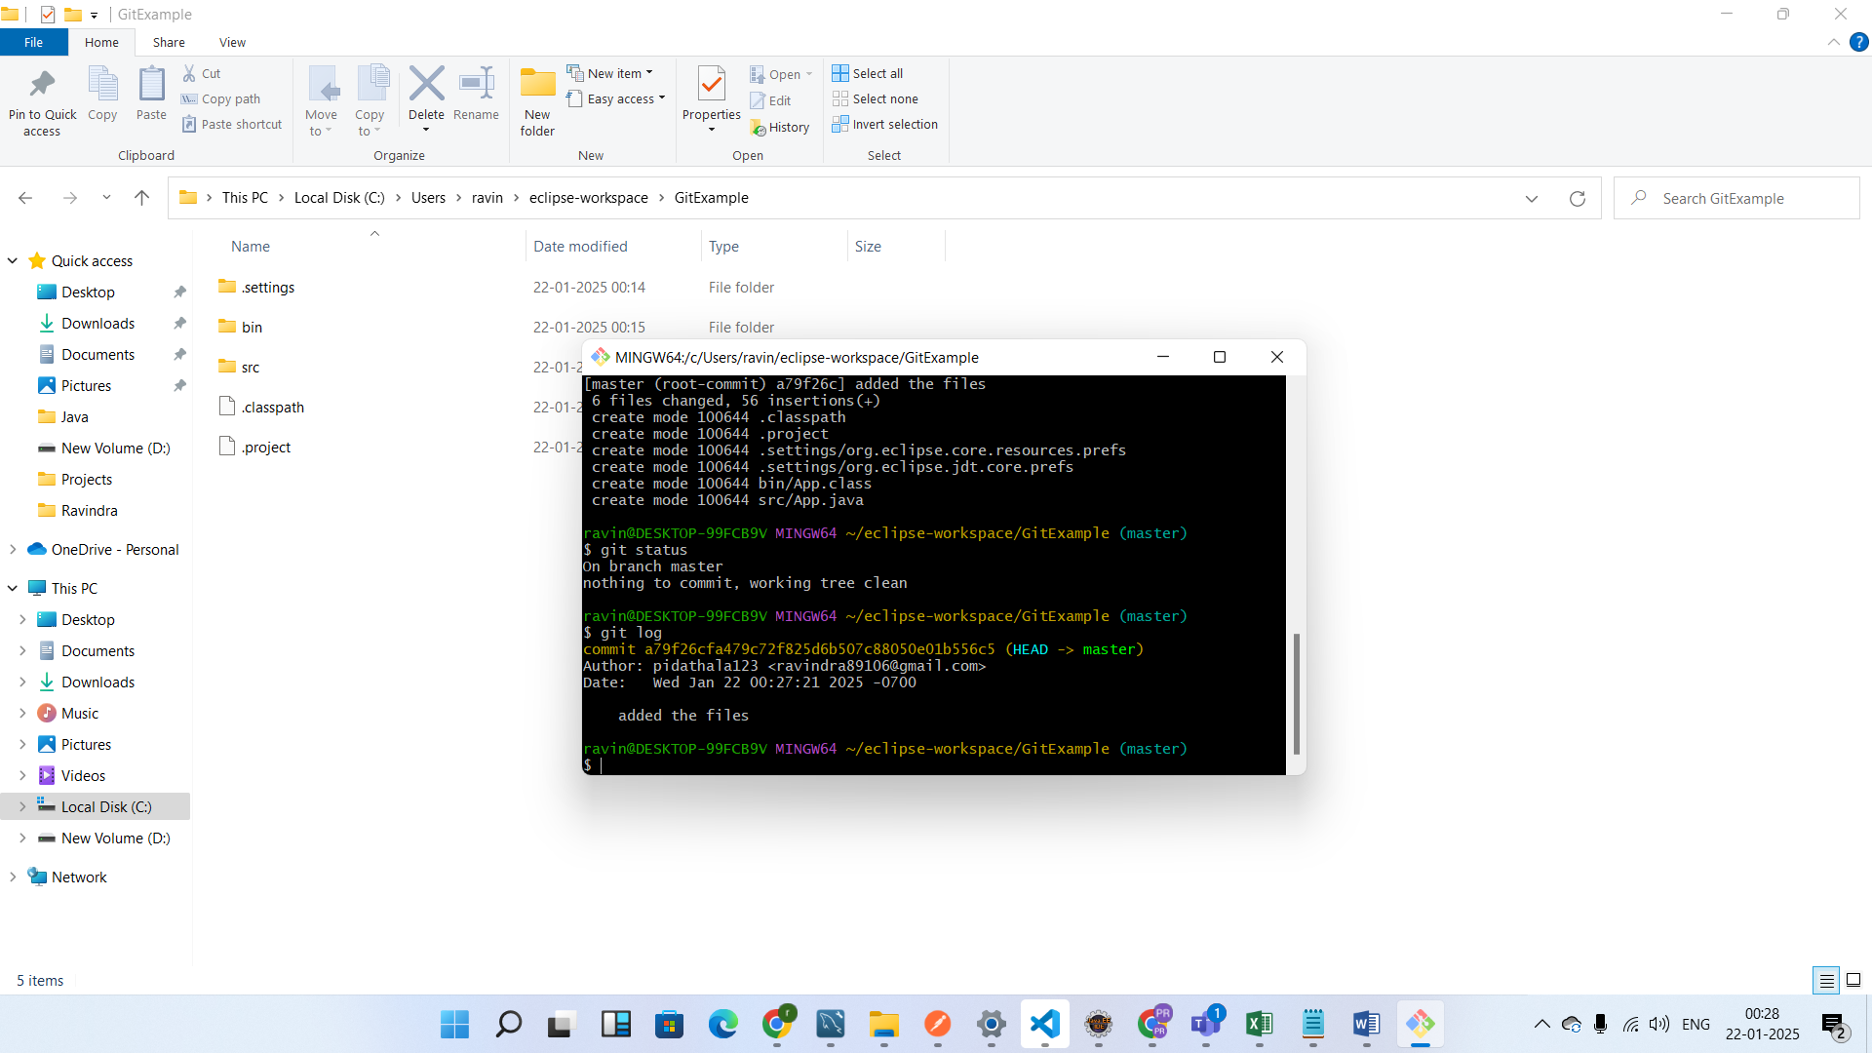

Now go to code do some changes

And again check git status

Use git add .

Git commit –m “message”

Next am going show u how to push local repository changes to remote repository.

For that u have to create the remote repository in github.

Click on + and select new repository

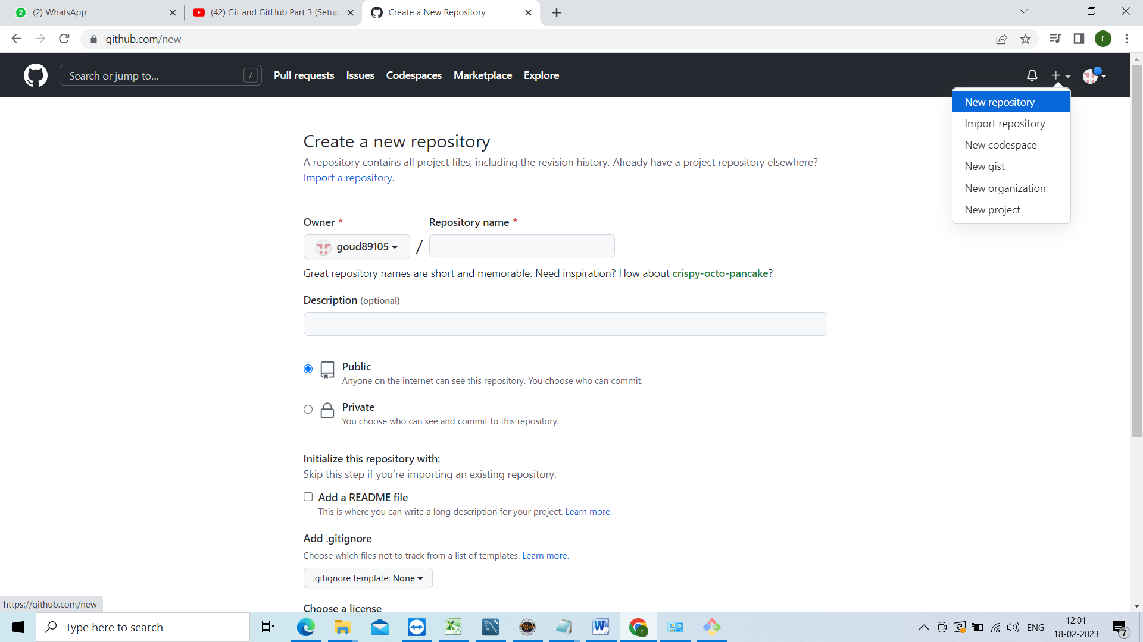

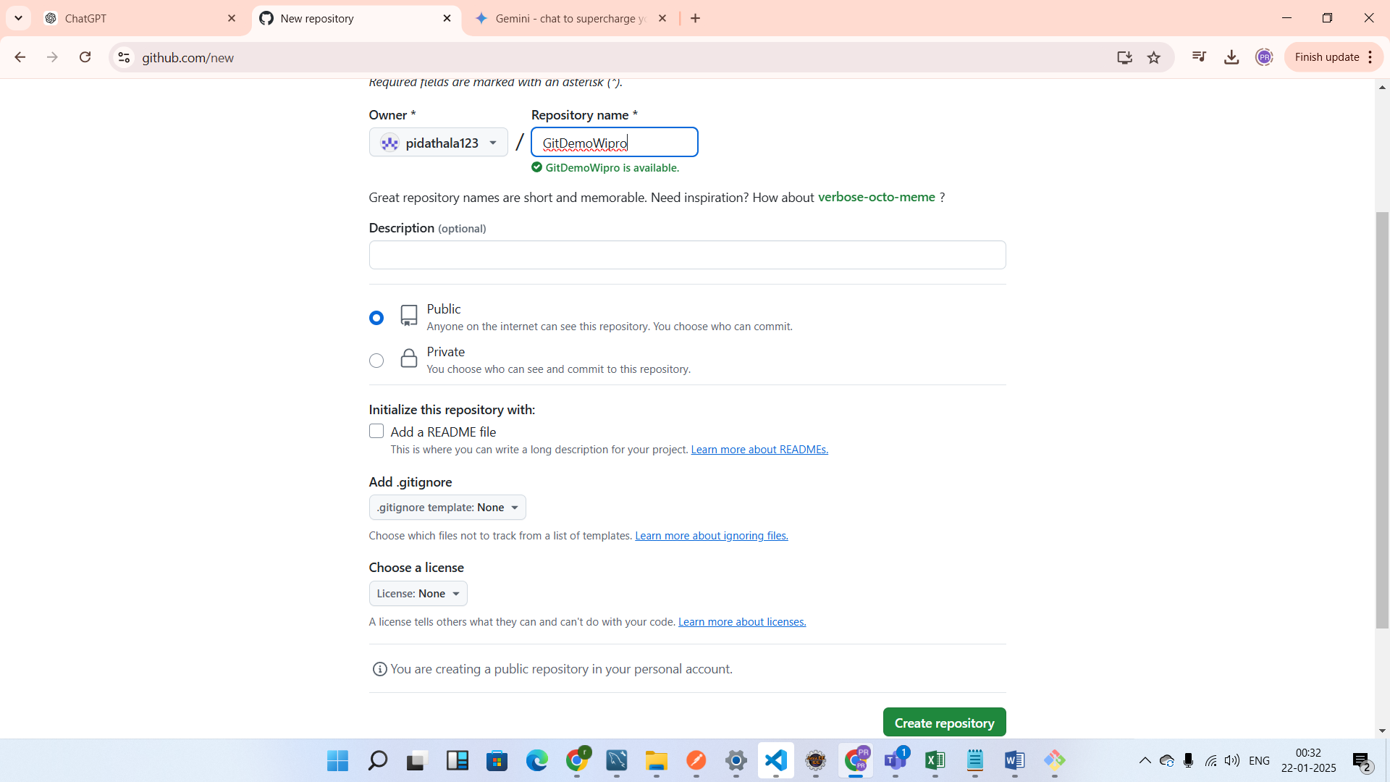

Click on create repository.

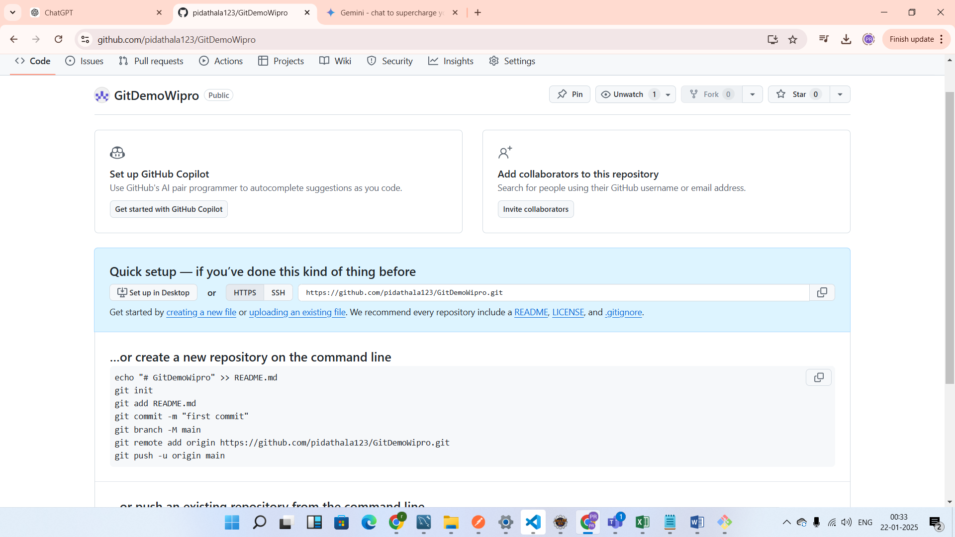

Now go to project directory which u have created previously do git bash from there.

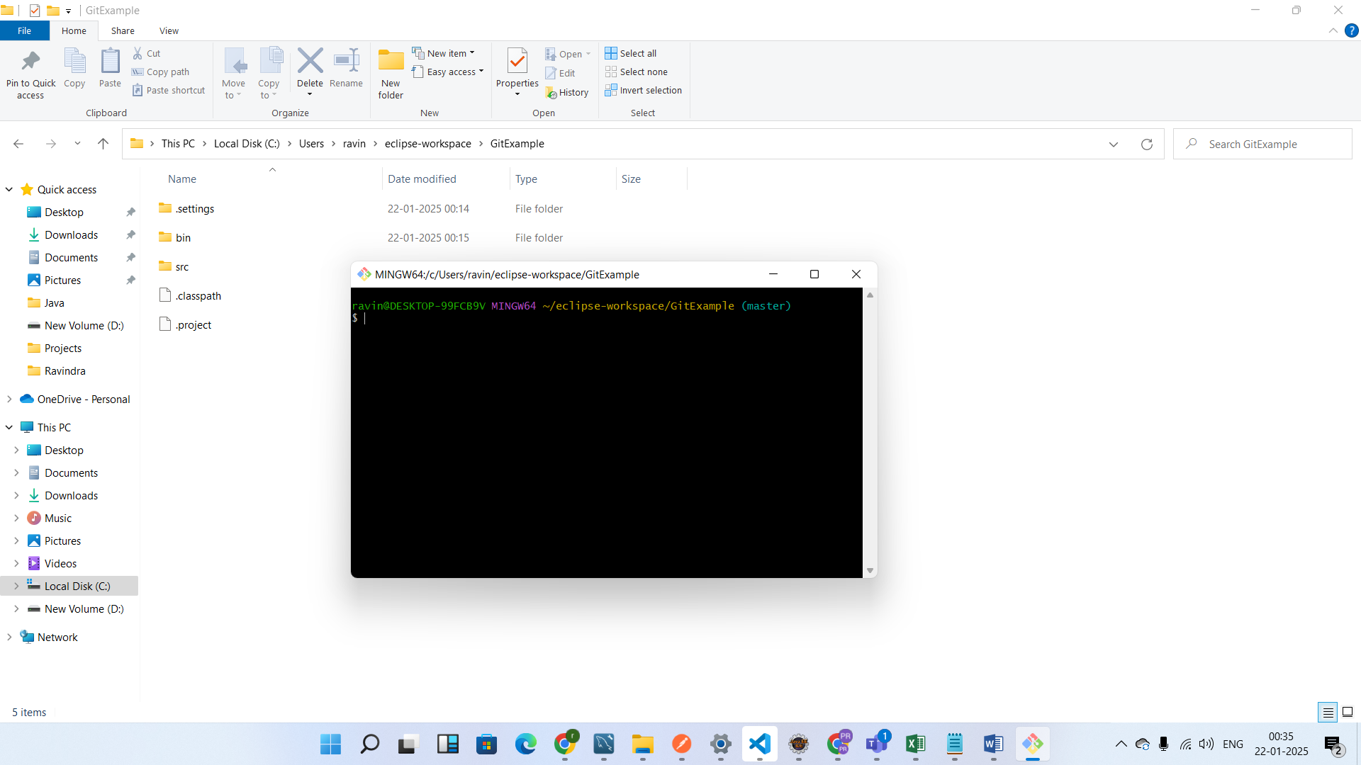

We need to set from local repository to remote repository to set that use below command

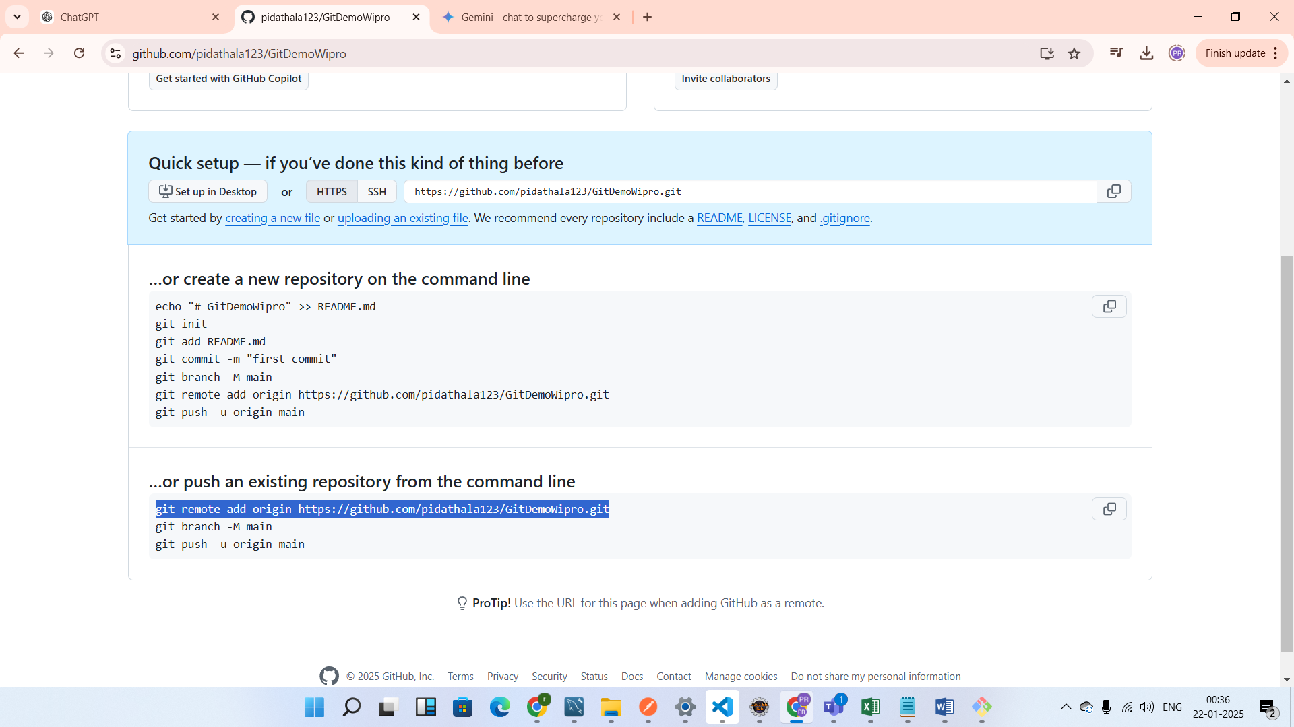

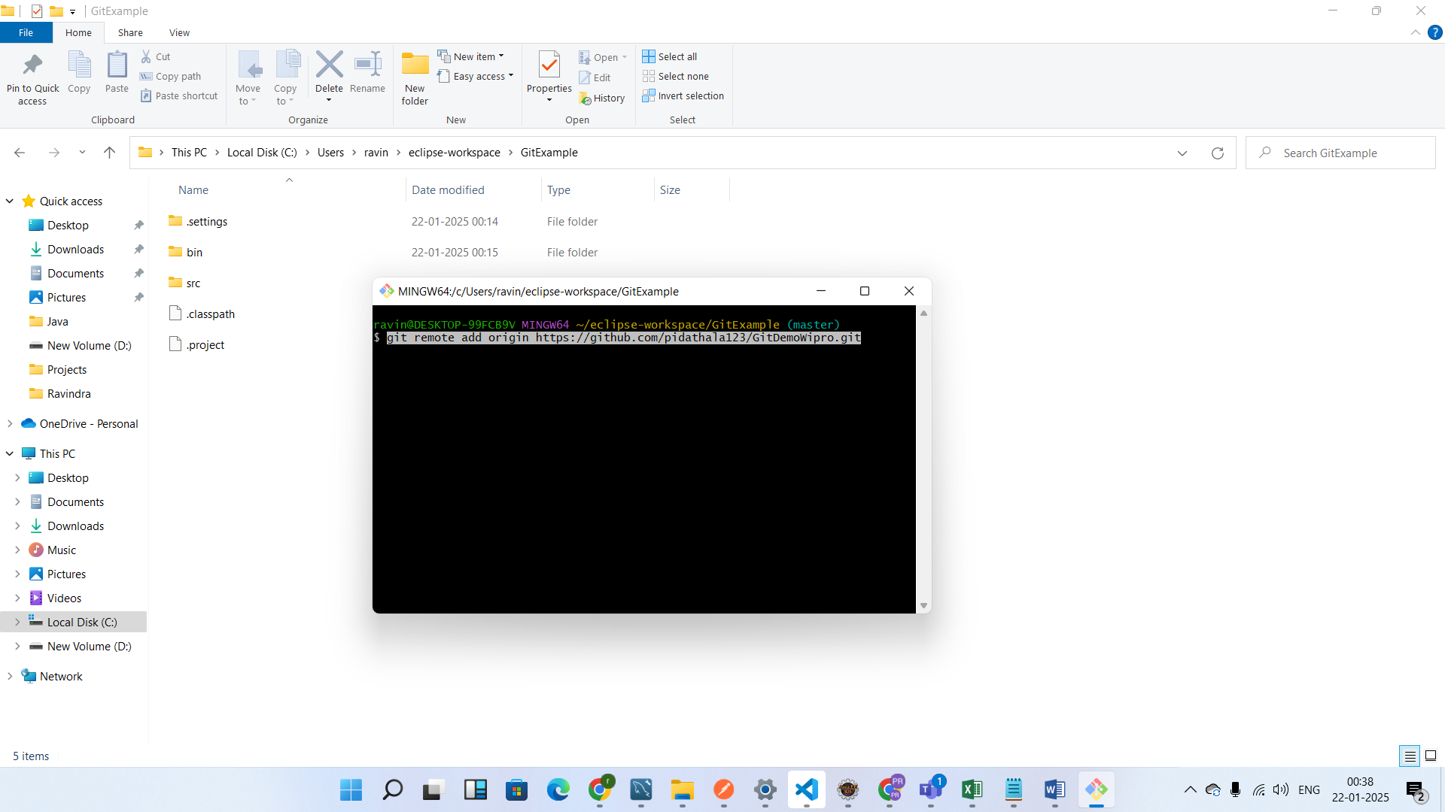

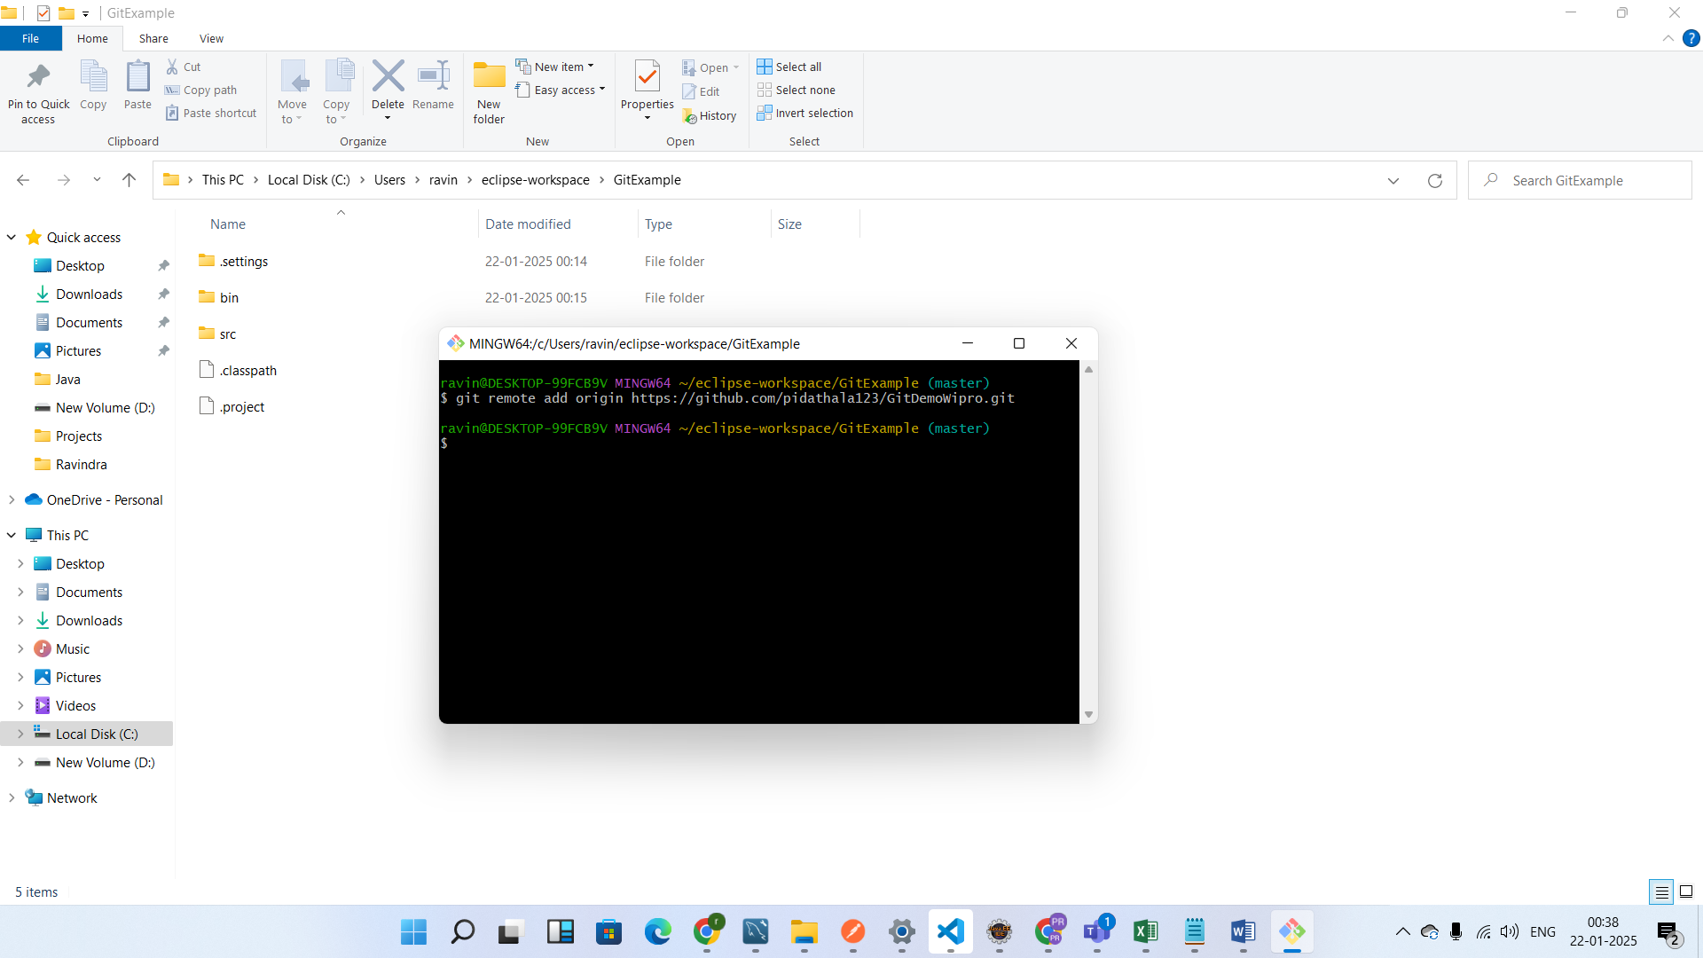

Now push our changes to remote repository

U se below command

Git push –u origin master

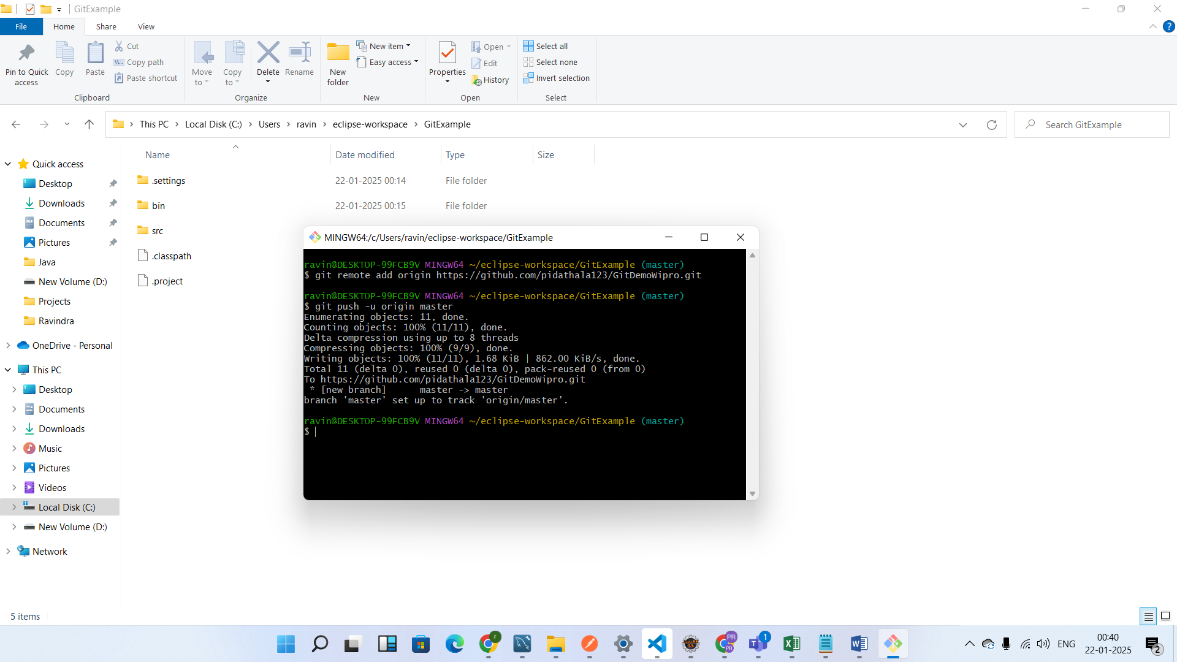

Now our local changes push to git hub

Go to github and refresh the page

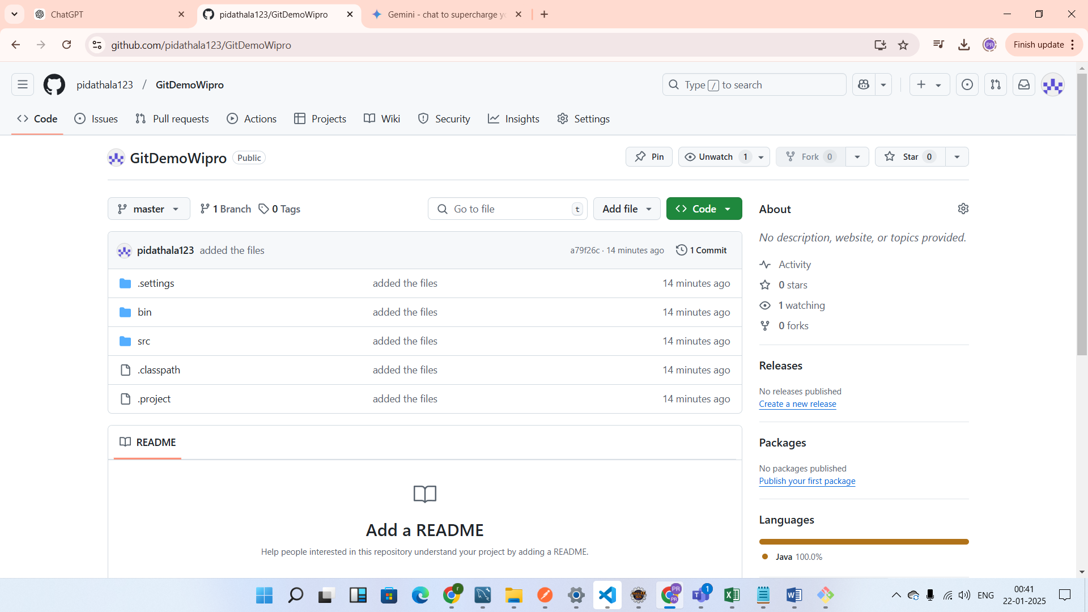

Assume u have joined the project newly they have given git link I will show how to checkout the code from github

Frist go to the any drive and create the folder and open the git bash from that folder and do git init

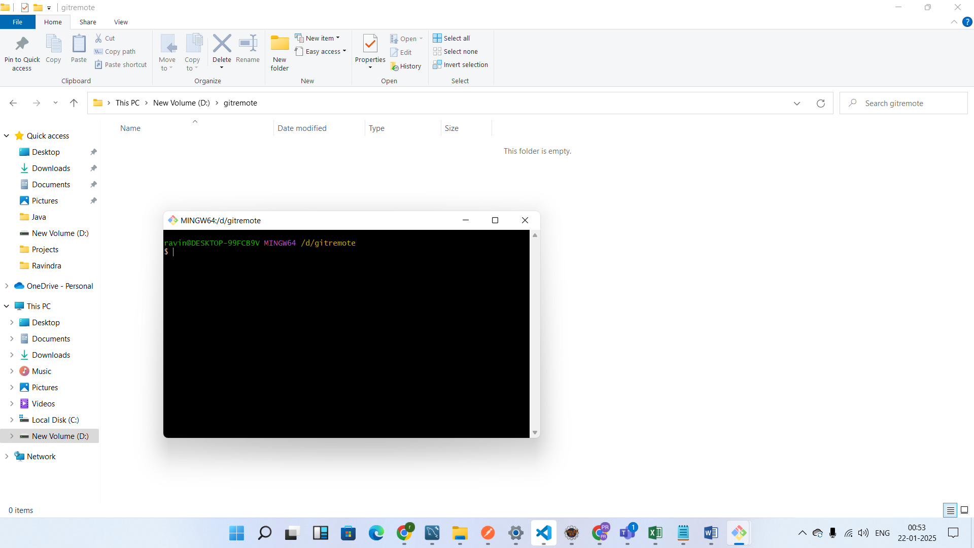

And now go to git hub and copy the link from below https

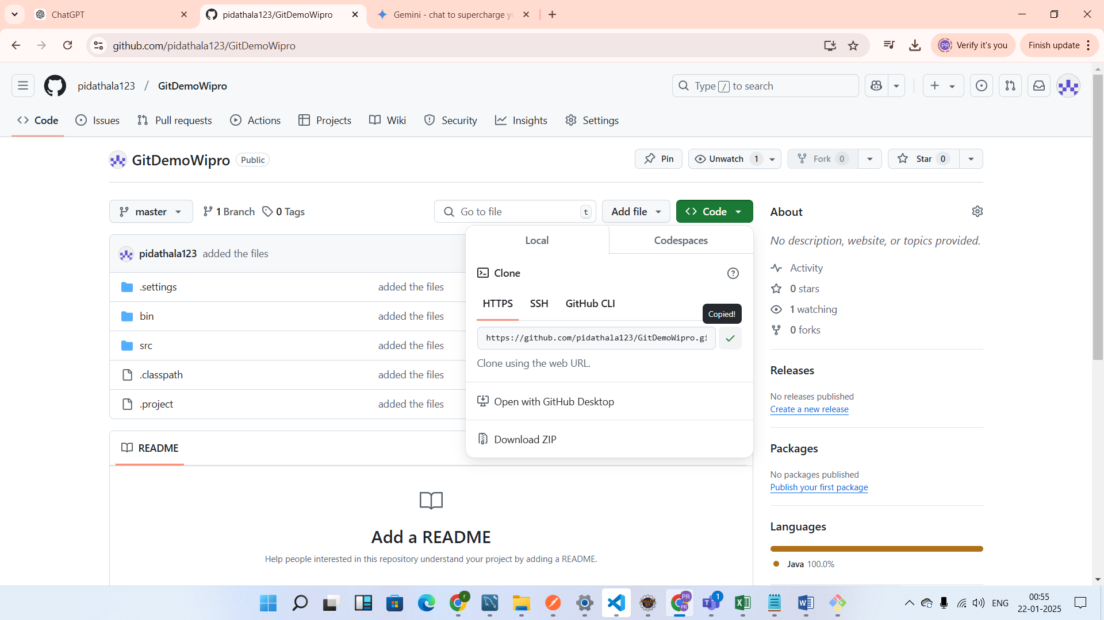

Now go to git bash execute the below command

Git clone URL

Git clone <https://github.com/pidathala123/GitDemoWipro.git>

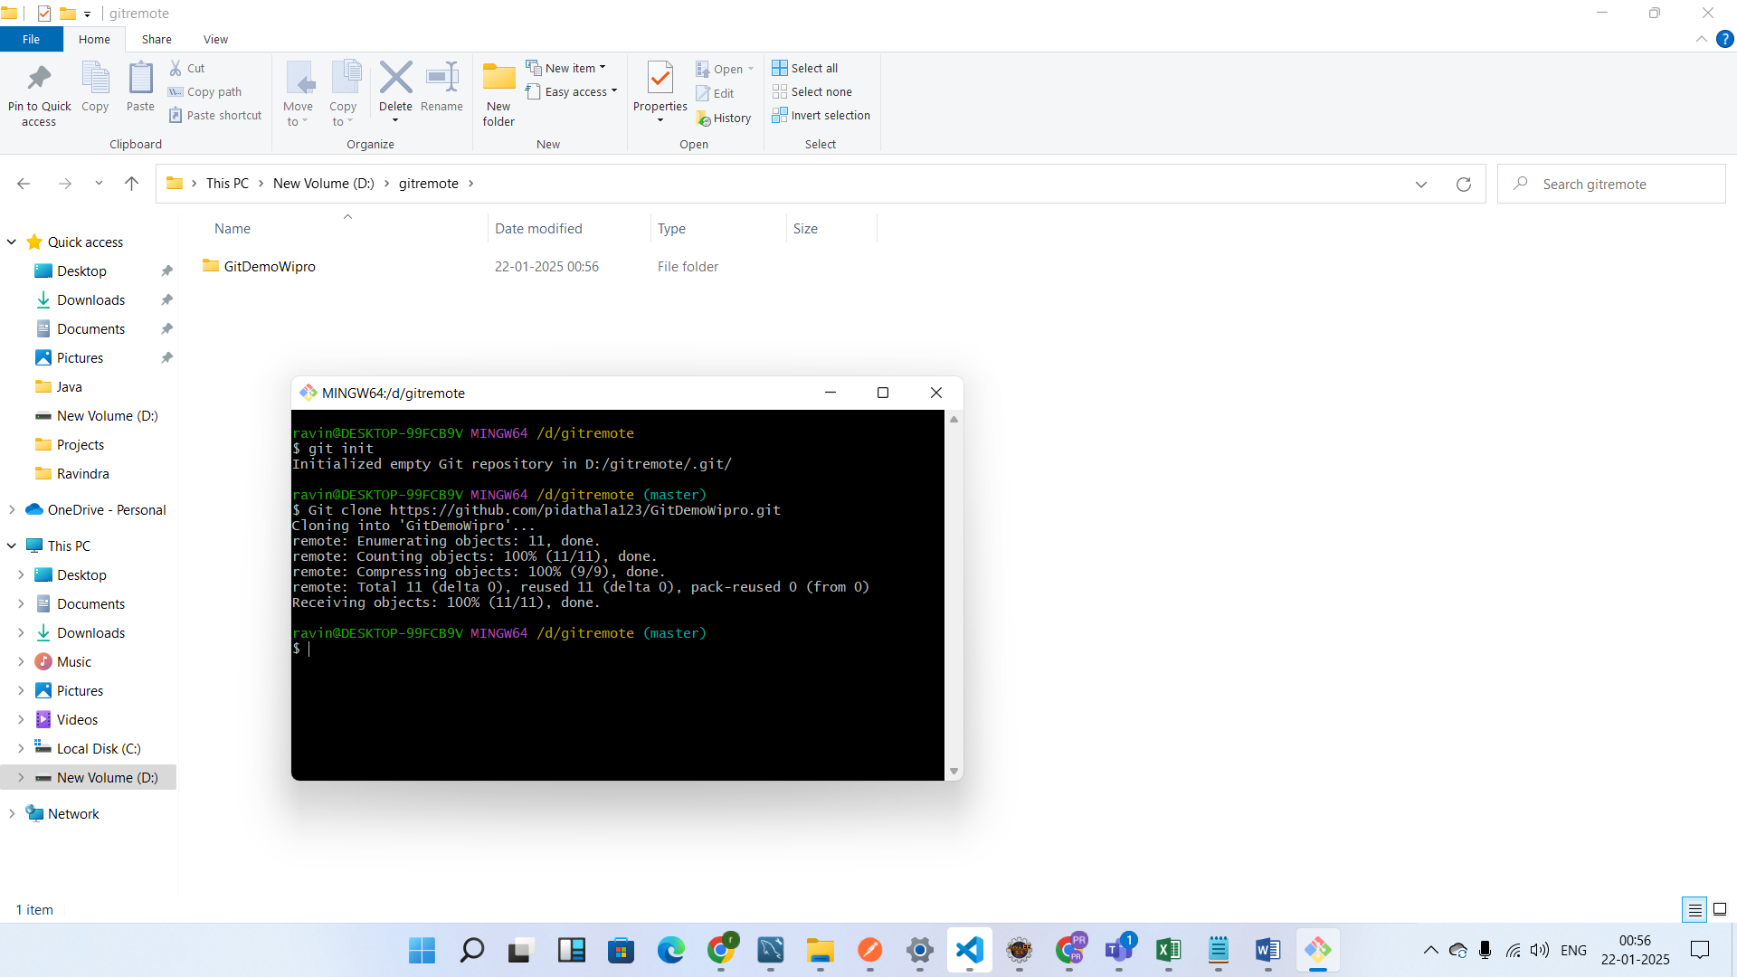

After that import the project in to eclipse

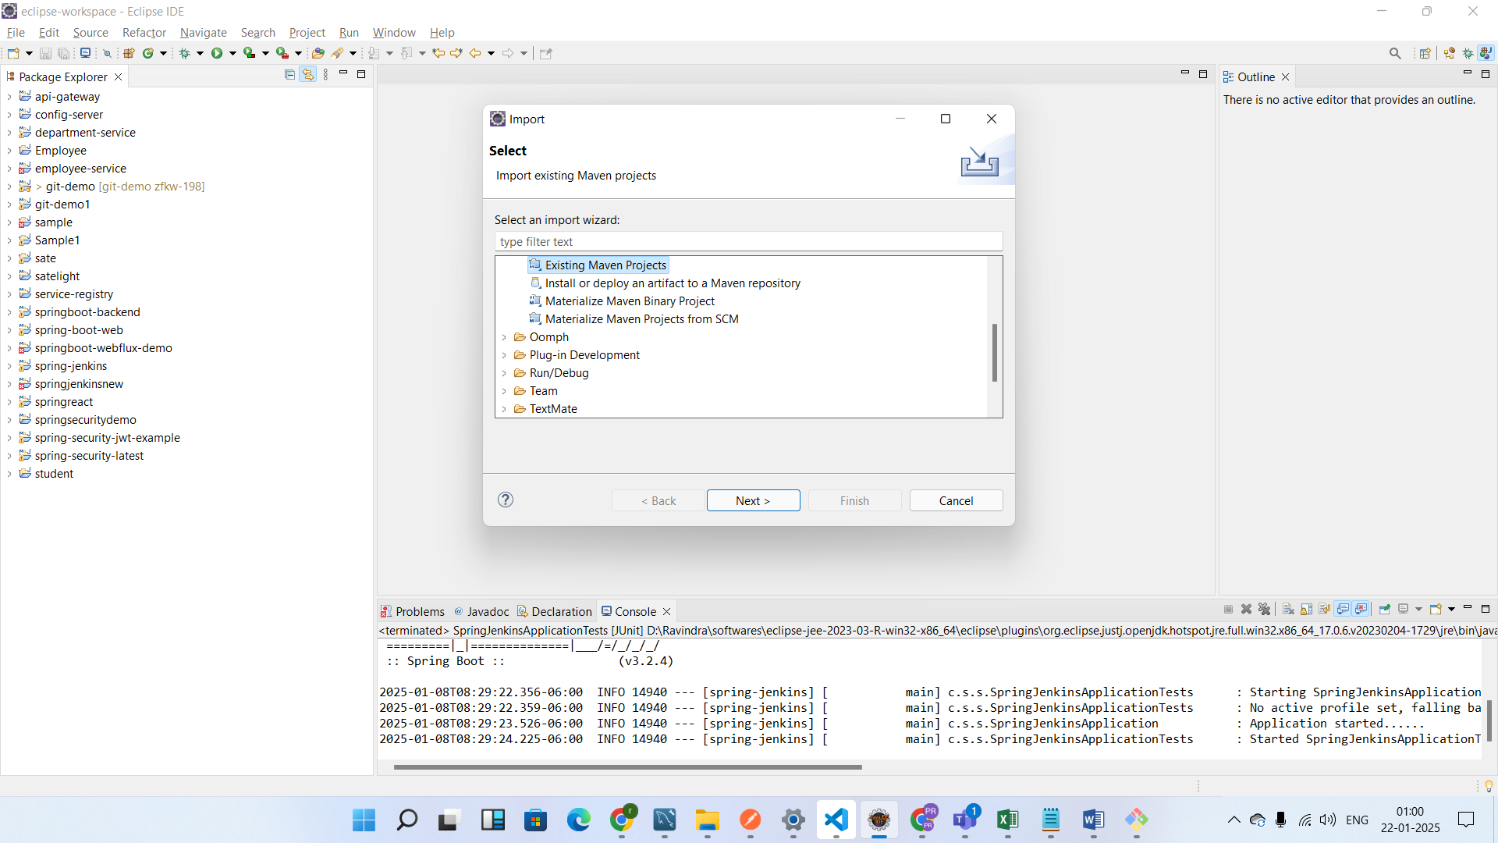

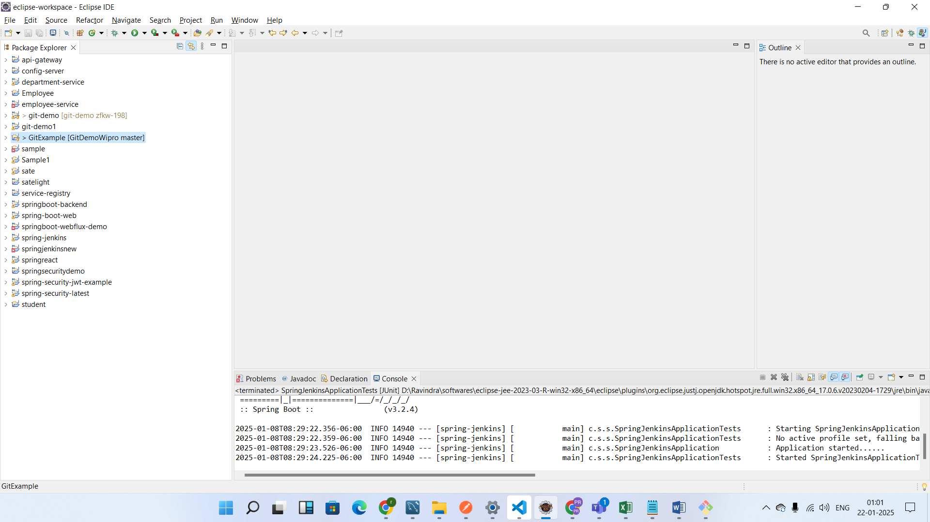

Before starting the task team member has to create the branch

Git checkout – b branchname

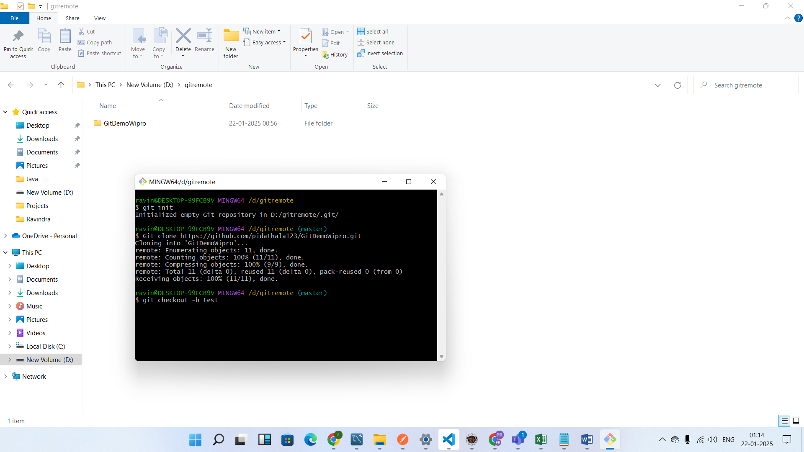

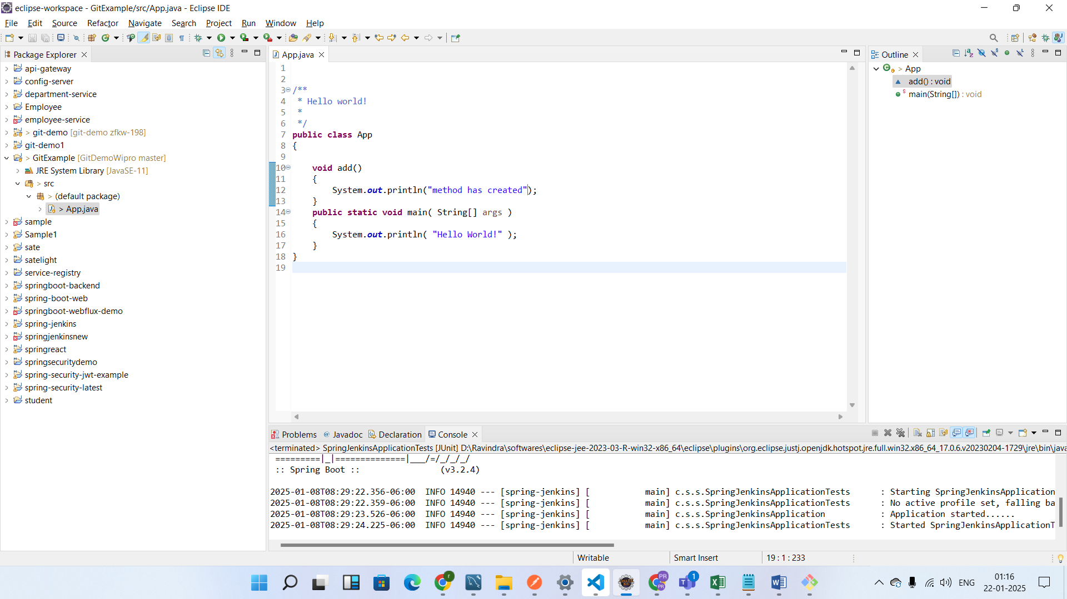

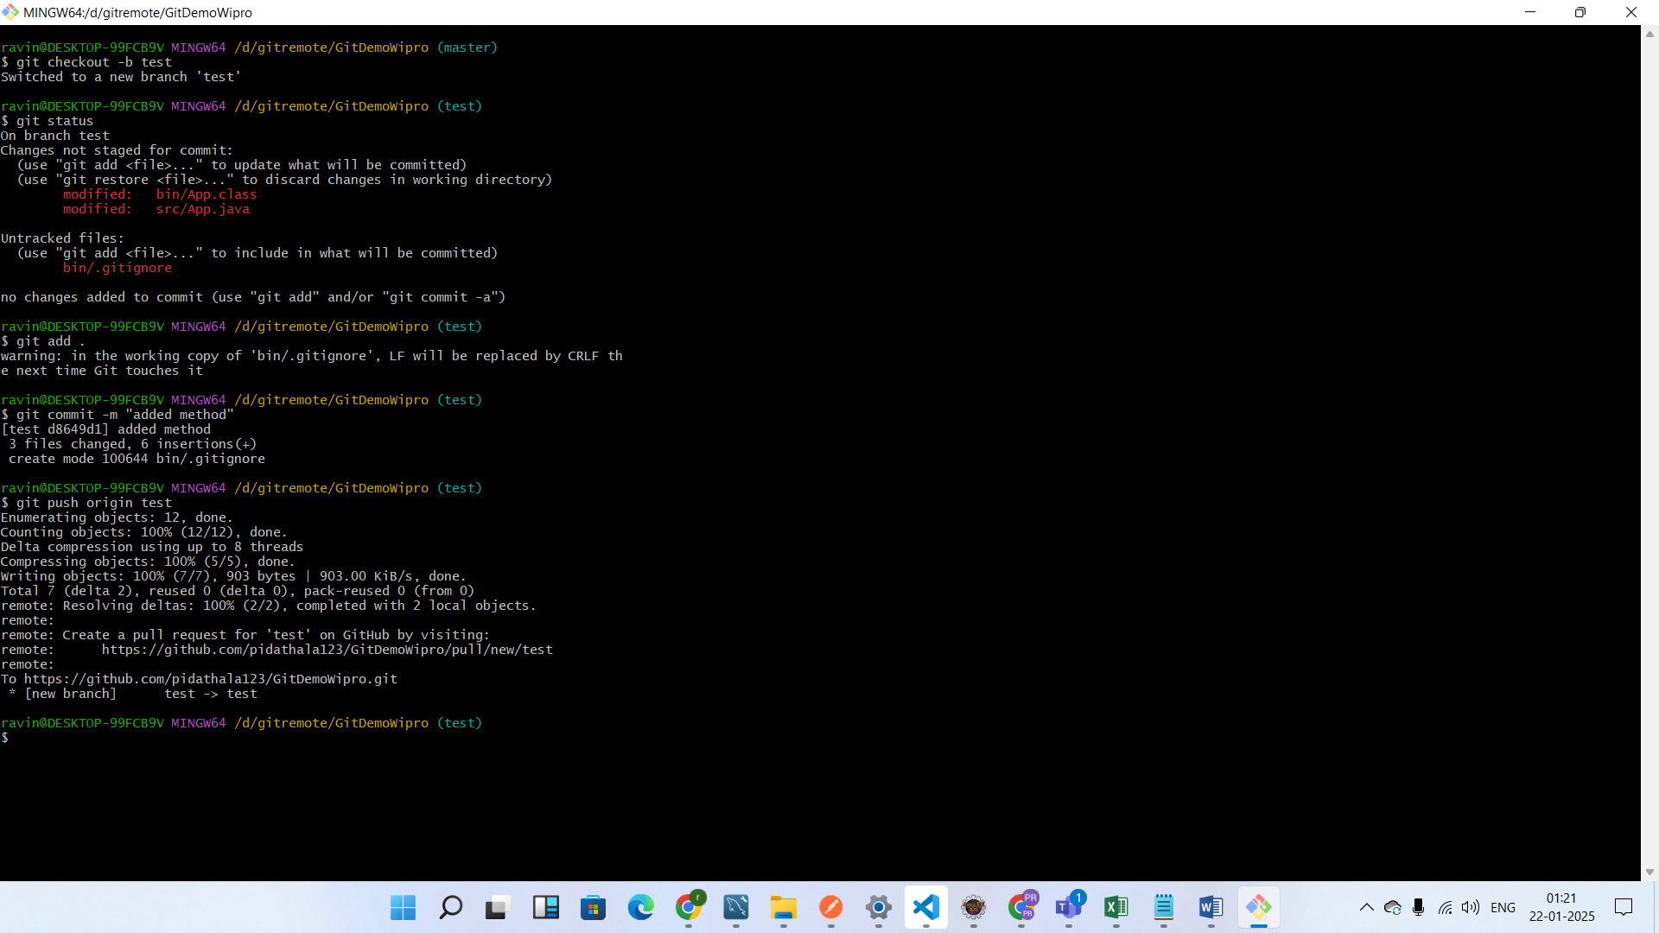

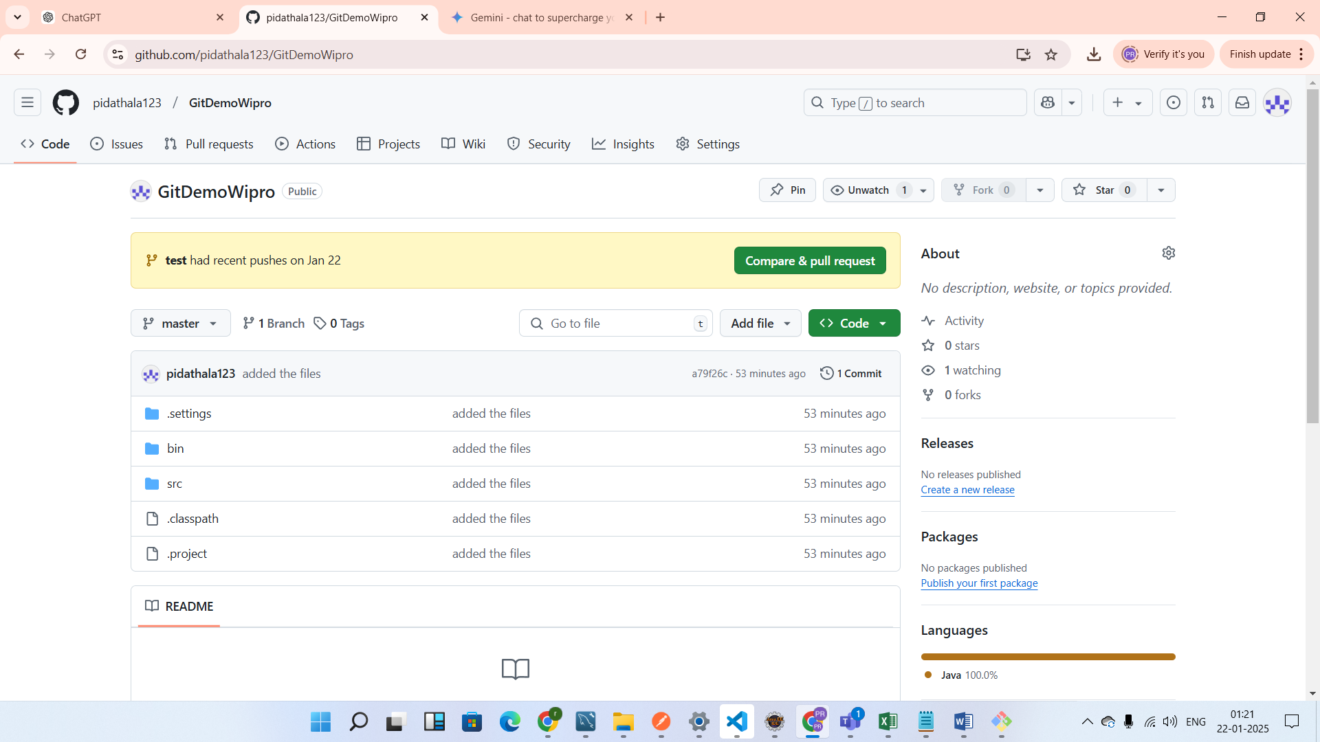

Now compare and create the pull request

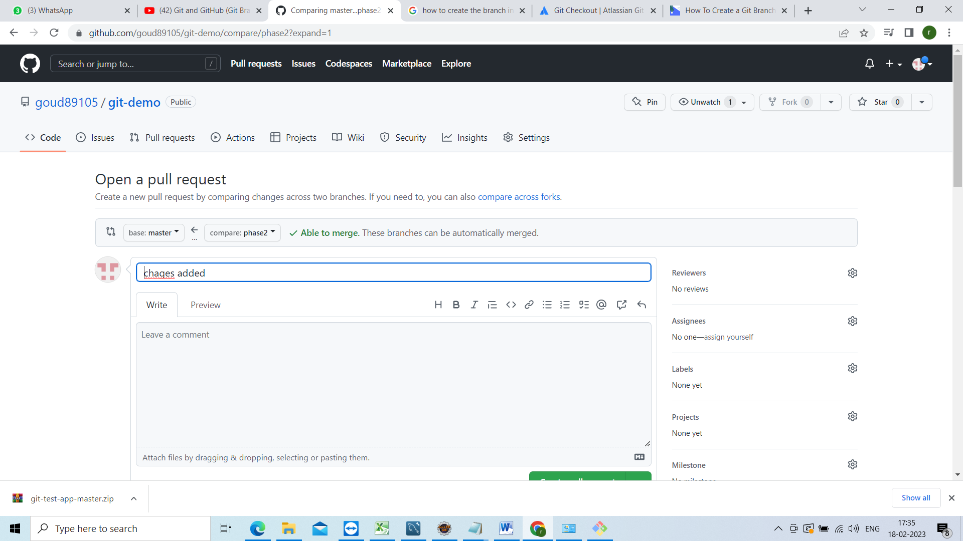

Now click on pull request

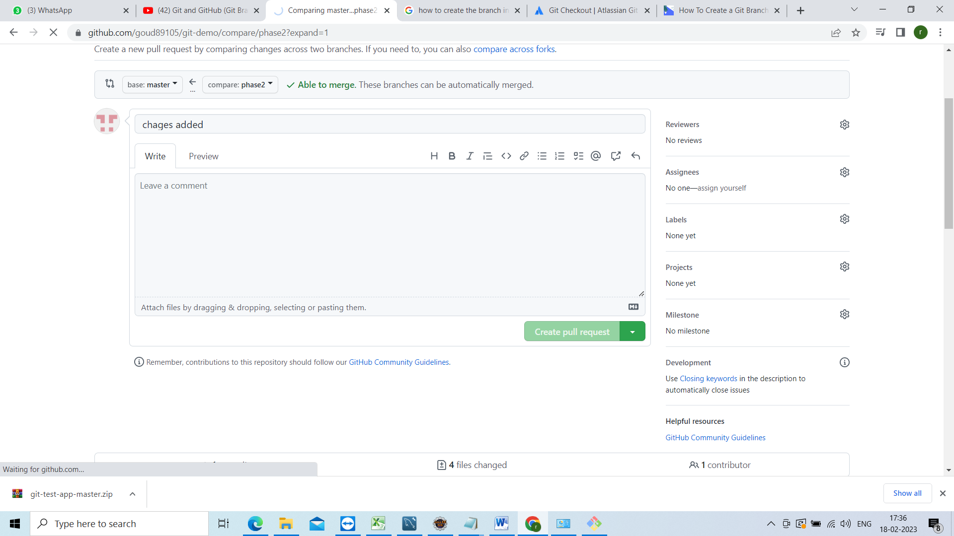

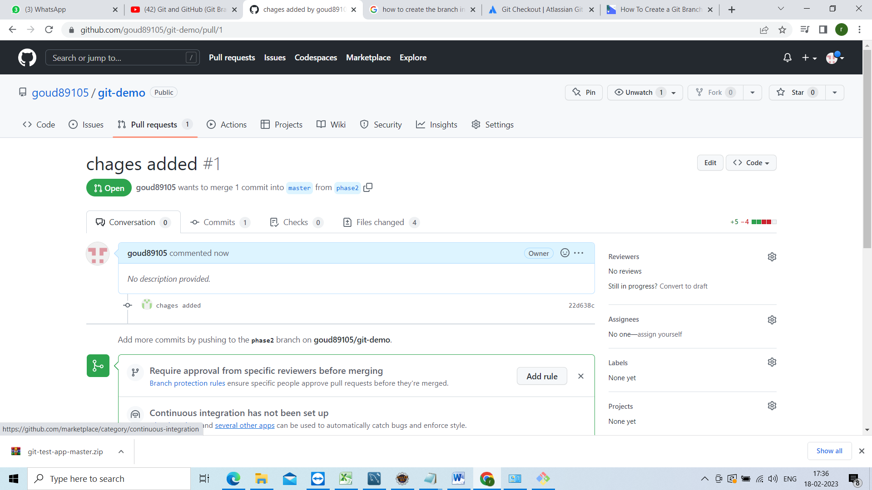

Now see this branch has no conflicts with the base branch

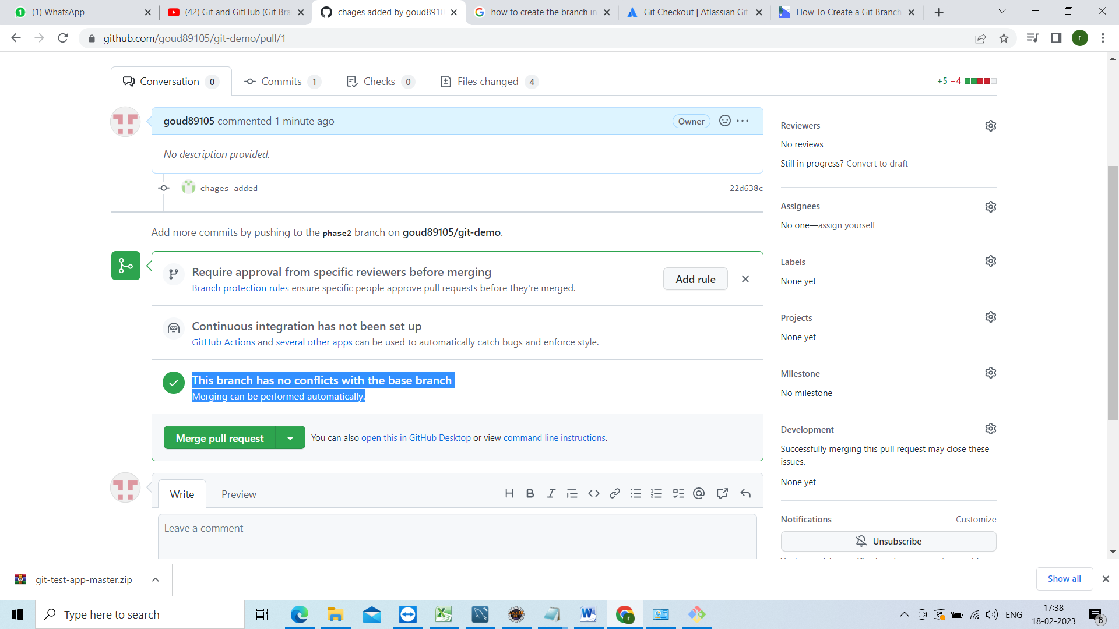

Before that lets check the changes click on files chaged

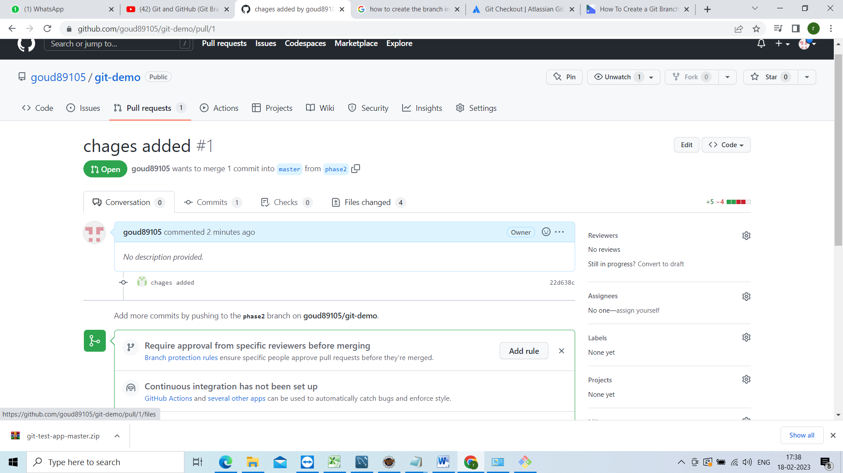

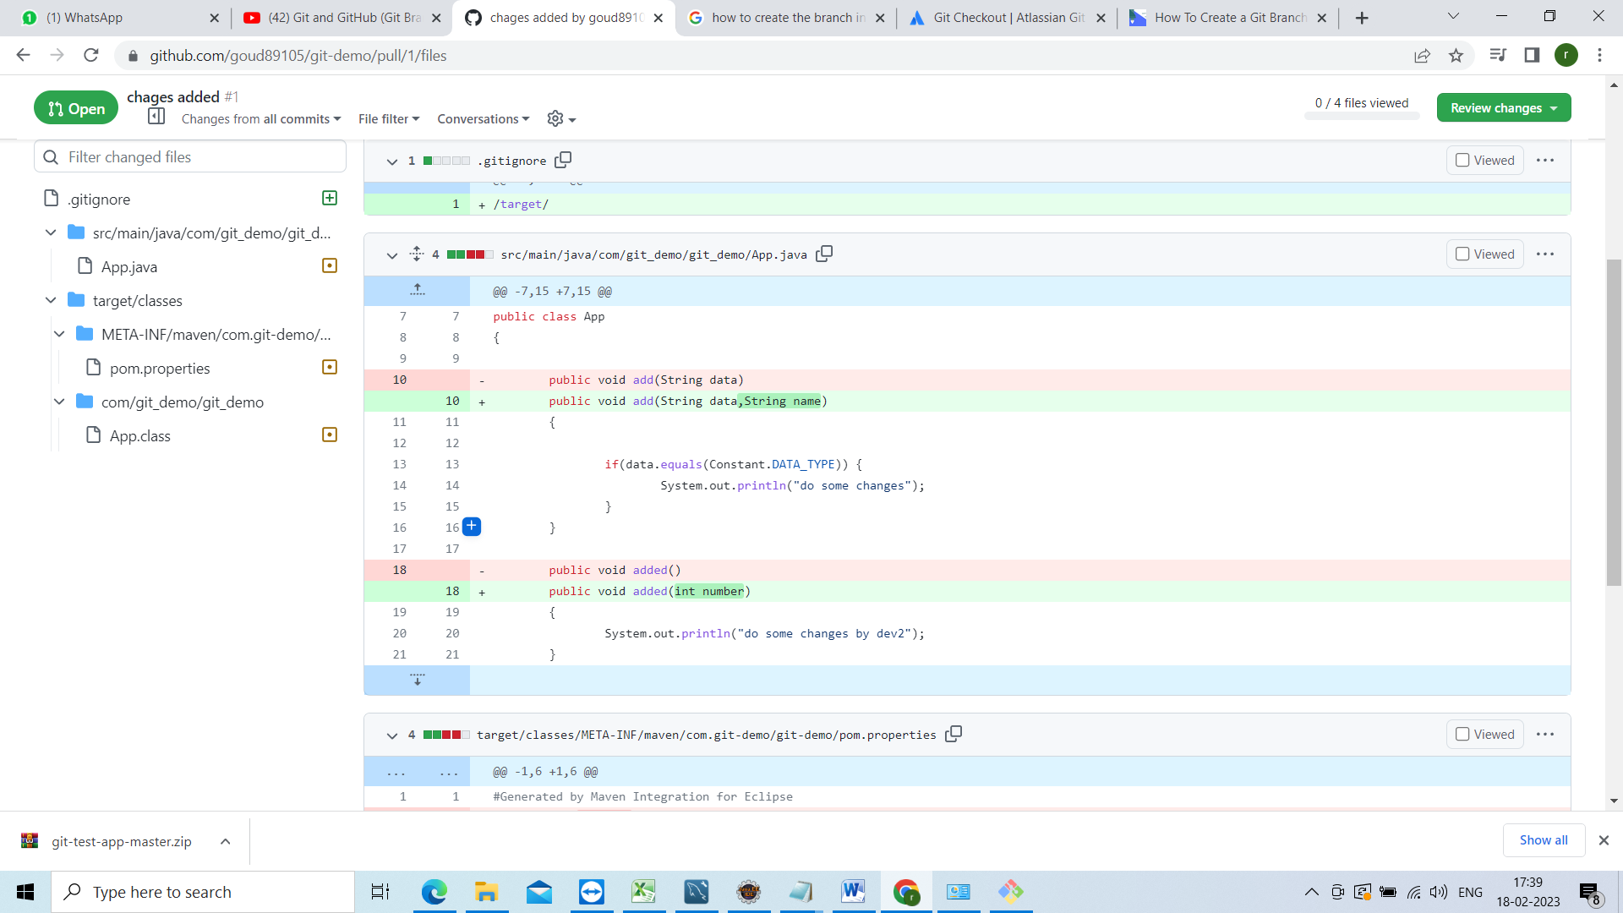

So that u can compare and can the review there

Now go back and click on merge pull request

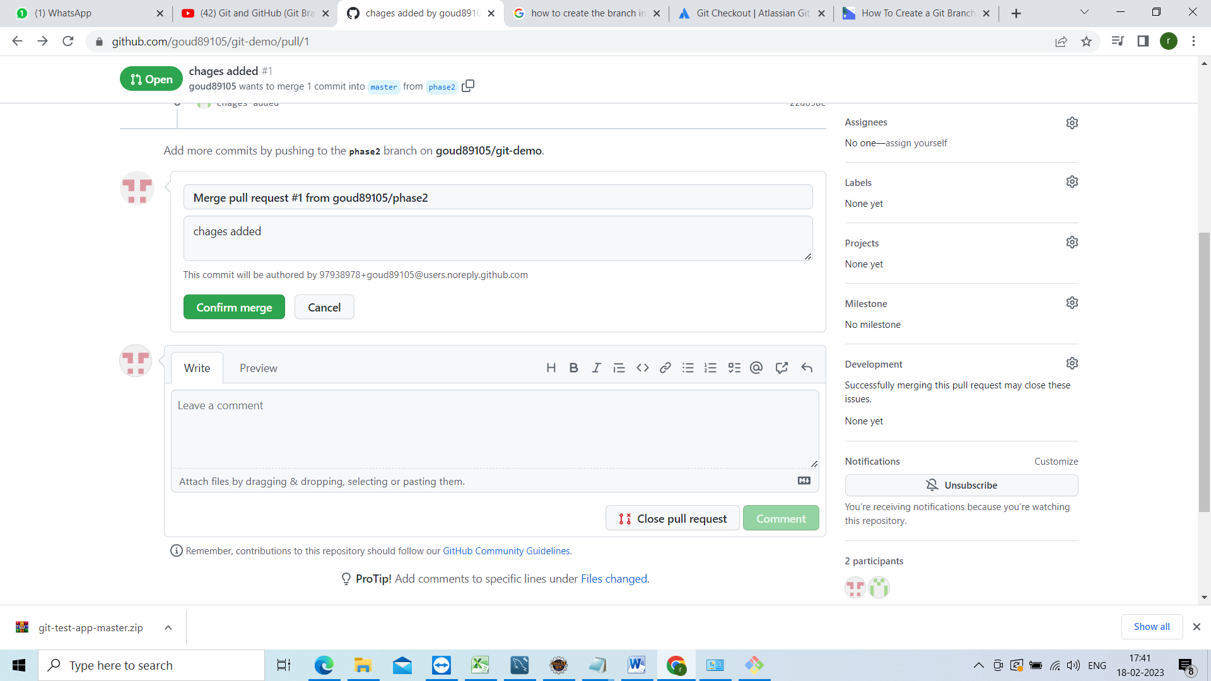

Click on confirm merge



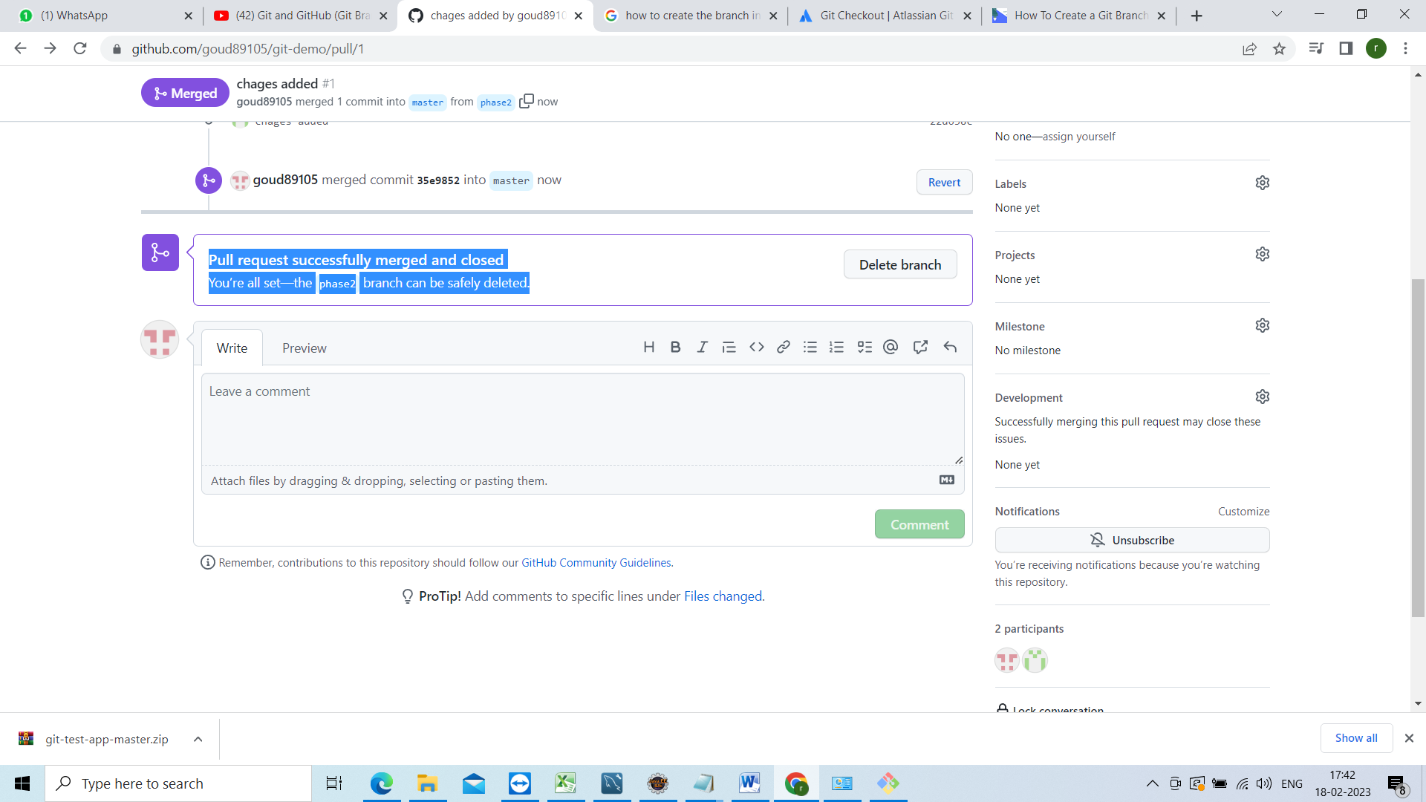

Now u have to give this pull request URL to ur team lead

<https://github.com/goud89105/git-demo/pull/1>

no go back and see this chages refleted or not

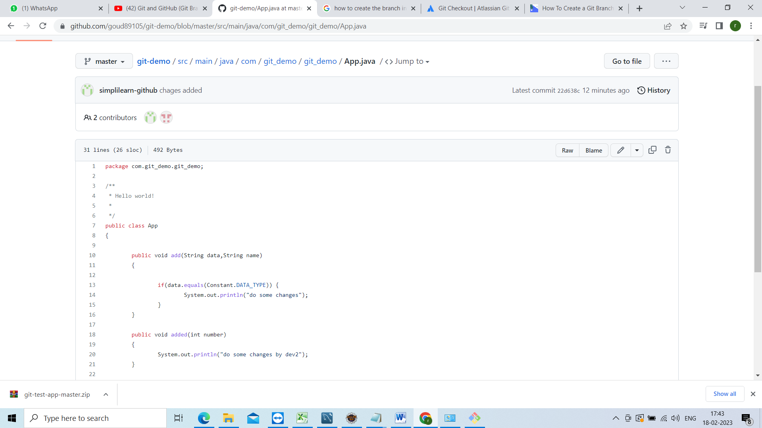

Now go to git bash changes are there in phase2 not in master changes wont come to master until u take pull

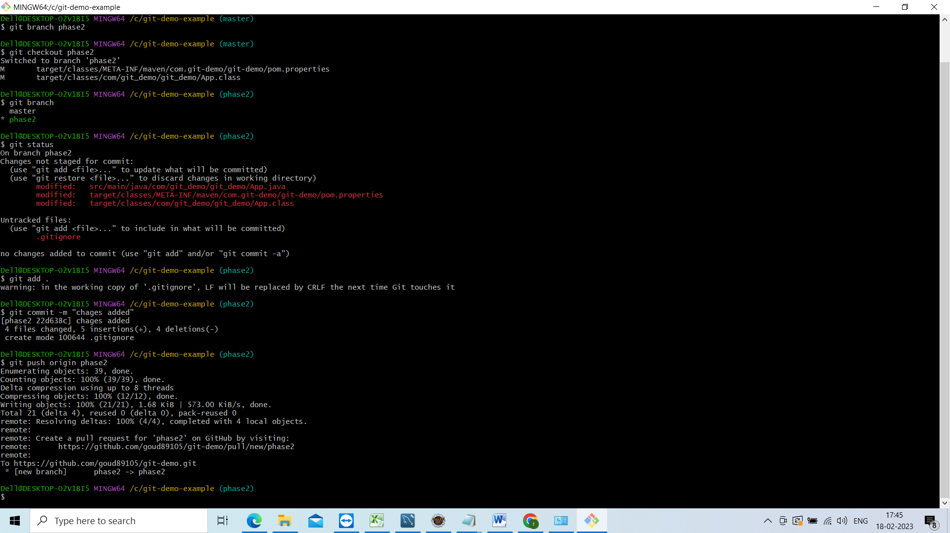

Switch to master branch

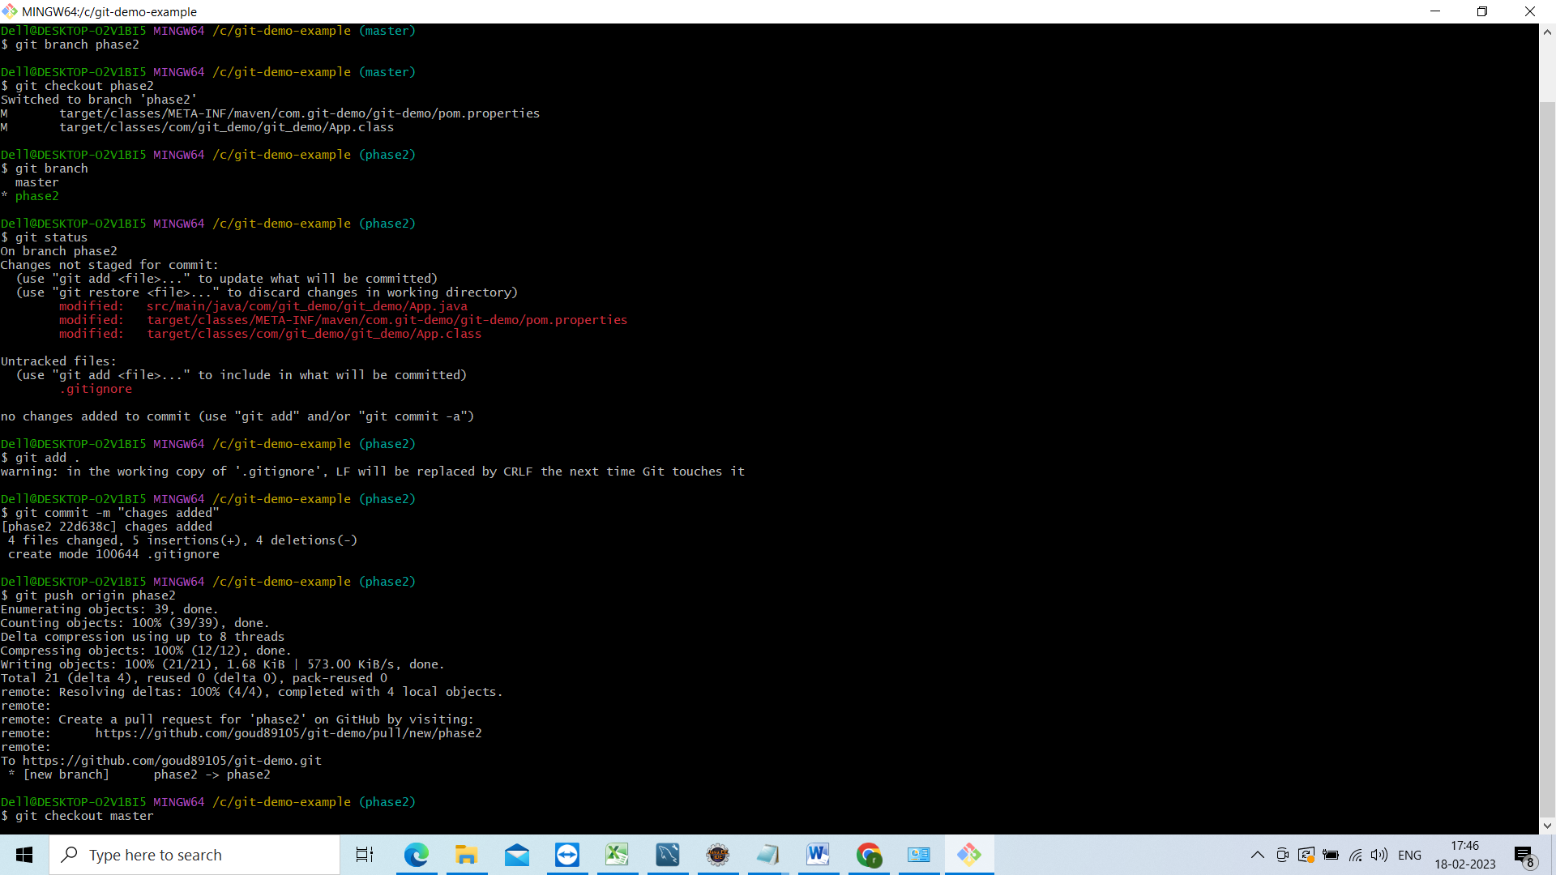

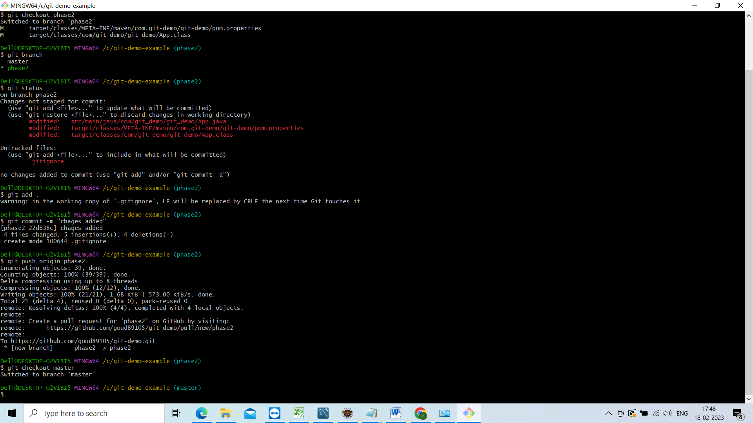

Now we are in master branch just clear the screen enter clear

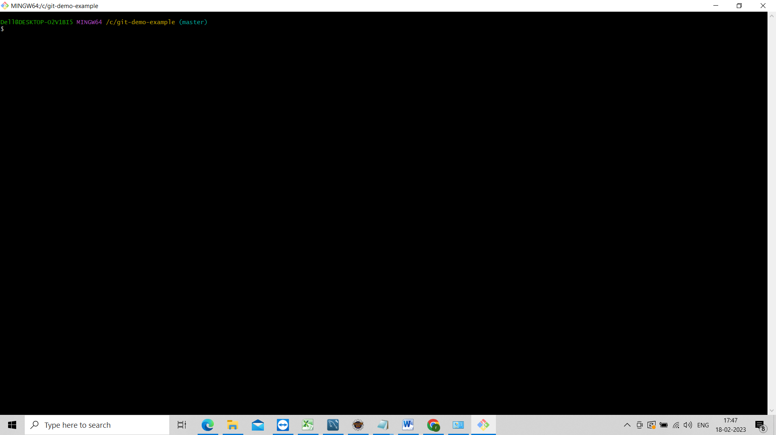

Now check git branch

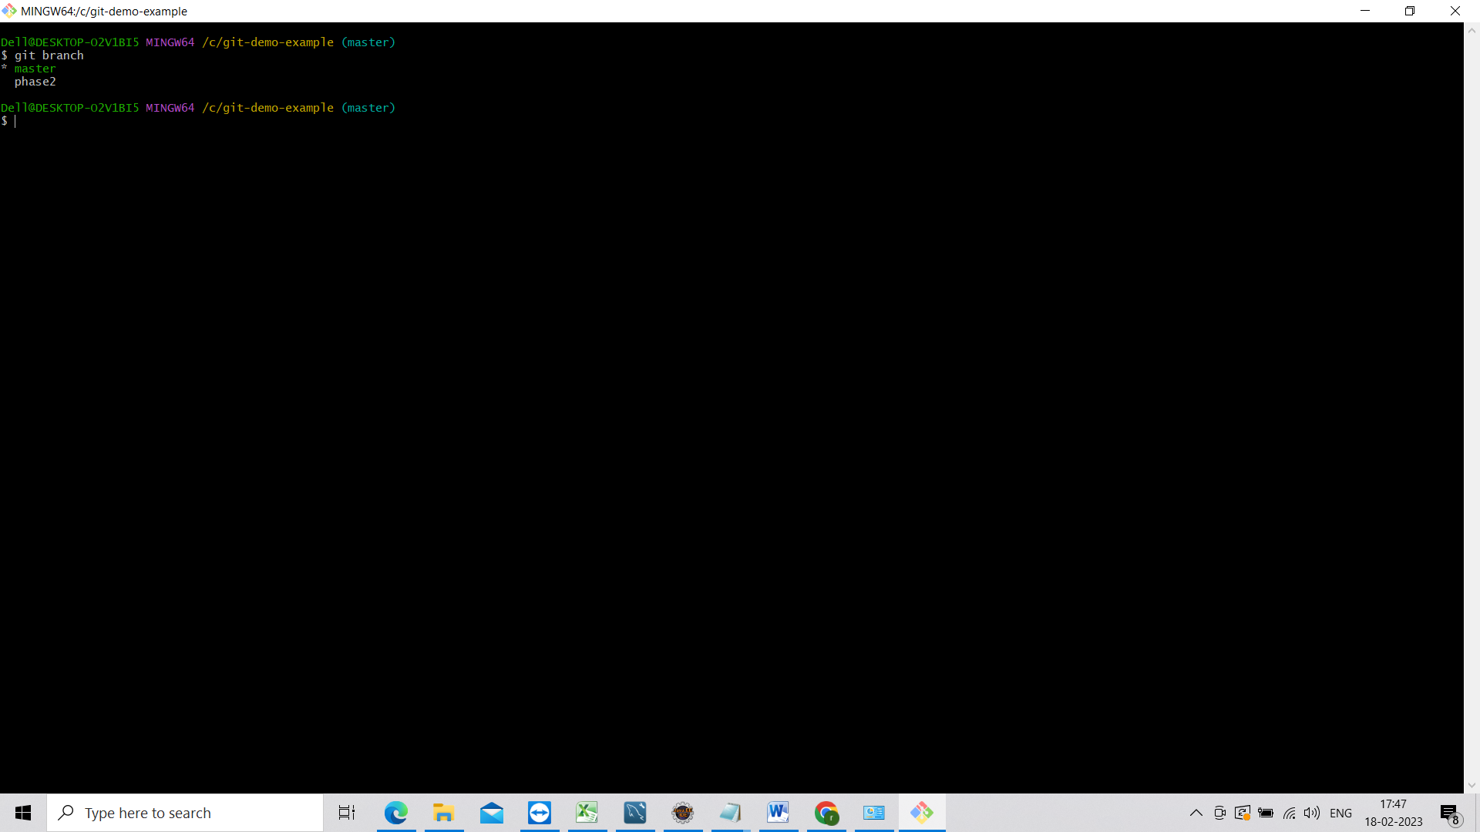

Now go to eclipse and see we are in master branch chages not refleted to the master branch

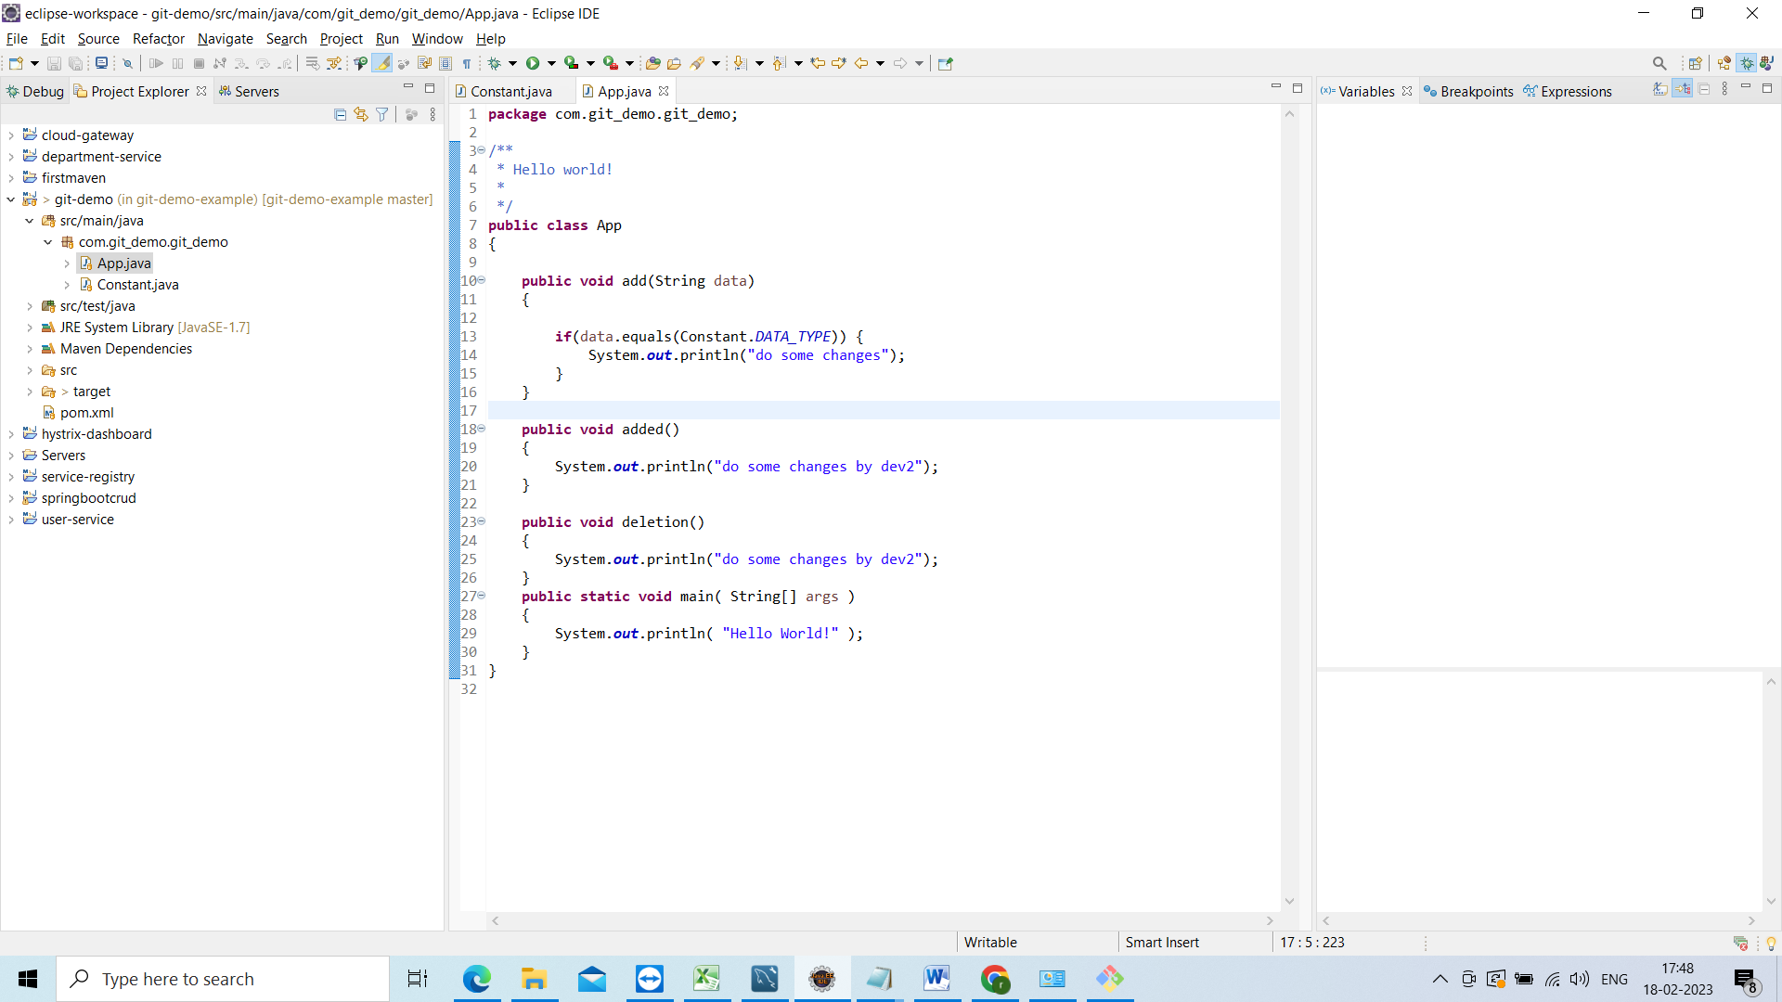

Now go to git bash and do pull

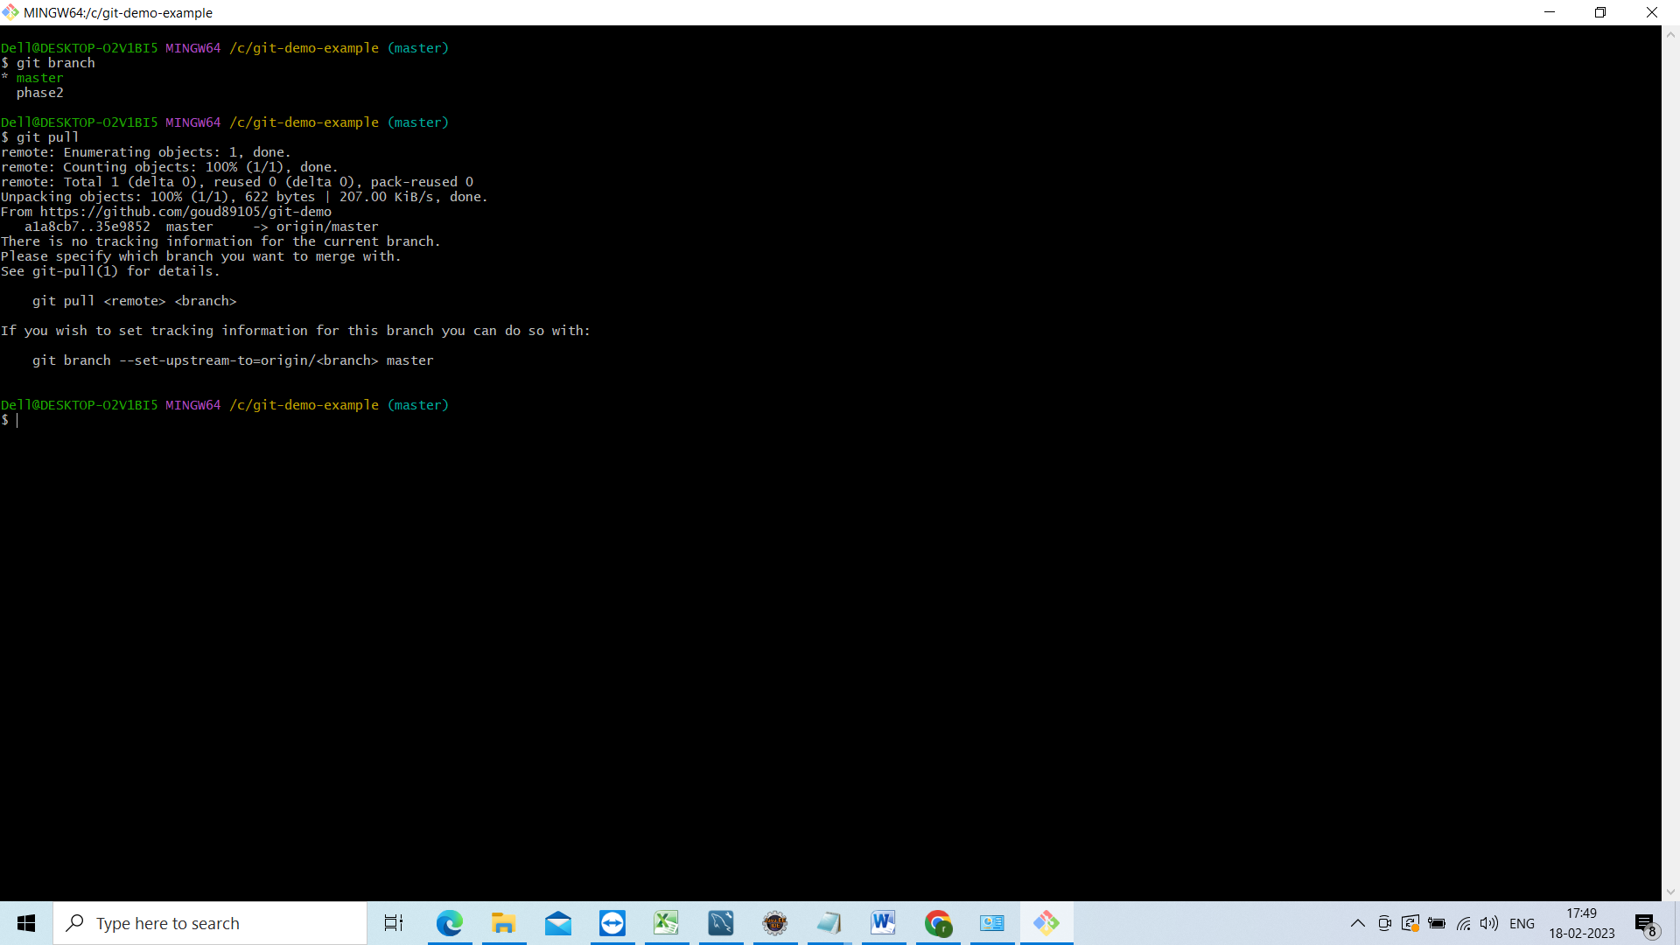

Now go to eclipse and see ur chages will be reflected in the master branch